Final Report

Group Name: UXplorers

Course: IS661

Date: May, 10th, 2024

**Group members:** Grace Burke (gnb5), Khushi Patel (kp836), Sai Leela Kuragayala (sk3679)



## 

## Table of Contents

Table of Contents 2

Contribution Table 3

Brief Description of Sections 3

Root Concept Table 4

Initial Deployment Strategy 5

Stakeholder List 5

Initial Target Demographic Breakdown 6

Professor 6

Student 6

Tech Entrepreneur 7

Problem Modeling 8

Persona List 8

Professors 8

Students 9

Tech Entrepreneurs 10

Personas 11

Professors 11

Students 13

Tech Entrepreneurs 16

Problem Scenario 18

Professor 18

Student 24

Tech Entrepreneur 30

Claims Analysis 40

Professor 40

Student 48

Tech Entrepreneur 49

Activity Scenario 51

Professor 51

Student 54

Tech Entrepreneur 56

Motivating Problem/Point of Intervention that guided your solution 60

Tech Audit 60

Claims Analysis 67

Key Path Scenario 72

**Appendix: 74**

## Brief Description of Sections

**Root Concept Table-** The root concept table introduces our unique solution and how our ideas will address the problem. Our basic rationale explains the technological advancements included in our solution.

**Stakeholder List-** The stakeholder list includes anyone who might use or be impacted by our app.

**Initial Target Demographic-** This is the initial demographics for our three main groups: Professors, Students, and Tech entrepreneurs. This includes various attributes that help us cast a wide array of personas (or in a real life scenario a wide array of research participants).

**Persona List-** Includes personas for each of the three sections that cover the variety of different demographic attributes.

**Personas-** More specific personas for each individual. Our main persona that we ended up focusing on was Julian Torres.

**Problem Scenario-** The problem scenario focuses on a 3 month experience for each of the three personas for each category. We explored how Julian, Sarah, and Mia would go about professional networking and the problems they might encounter to discover problems that need solutions.

**Claims Analysis -** The claim analysis aims to find positive and negative aspects from the problem scenario storyboard from our main personas mainly Julian, Sarah, and Mia to better understand the problem and craft our activity scenario.

**Activity Scenario -** The activity scenario is like a magic carpet that uses the claims from the problem scenario in order to craft a story that can act as a solution without considering the logistics of it and considering other factors.The activity scenario follows the same scenario as the problem scenario but aims to fix the problem.

**Tech Audit-** The Tech Audit looked at existing technology within this space to gather ideas and inspiration.

**Claims Analysis-** This section includes claims (positives/negatives) for the activity scenario, which explores what features of the activity scenario might be able to be improved upon and helps to see which ideas could be improved upon.

**Key Path Scenario-** This section focuses on our key idea– icebreakers and helping to make first connections easier as well as helping to foster those connections with an AI assistant. It includes screen requirements, and a video that links to the keypath, additionally it features a link to the UI.

## Root Concept Table

[ChatGPT Link](https://chat.openai.com/share/303ea5bf-57a2-43ef-8027-8abbfd2bbf8d)

[ChatGPT Link](https://chat.openai.com/share/56b2eb93-341b-4297-8b40-0c6e8defc2c9)

[ChatGPT Link](https://chat.openai.com/share/e1ed5991-5ccd-440e-8f2d-22a27291167f)

[ChatGPT Link](https://chatgpt.com/c/622ab03e-221f-4998-9196-327423d4c3fd)

|  |  |
| --- | --- |
| **Component** | **Contributions to the root concept** |
| High-level vision | In professional networking, discovering common ground with others isn't always straightforward. A shared connection or past event can significantly ease the process of making new contacts. Icebreaker is designed to tackle these challenges head-on by highlighting shared interests and suggesting conversation starters. With our innovative solution, awkward introductions and forgettable conversations become things of the past. Icebreaker also helps to build on initial interactions with a chatbot assistant that gathers notes post-meeting and suggests follow-up actions, which is essential for building lasting professional relationships. |
| Basic rationale | By leveraging NFC technology, Icebreaker enables attendees to connect through a simple tap of their badges. The app utilizes AI-driven web scraping to gather detailed information from professional platforms like LinkedIn and ResearchGate, enhancing the depth of its profile analysis. This enriched data allows Icebreaker to generate personalized icebreakers and conversation starters. Additionally, Icebreaker’s AI chatbot, equipped with generative AI capabilities, assists in capturing key meeting details and formulating strategic follow-up conversations. This multifaceted approach not only improves the immediacy and quality of connections but also significantly boosts the potential for sustaining these relationships long-term, addressing key challenges in traditional networking methods. |

## Initial Deployment Strategy

## Stakeholder List

[ChatGPT Link](https://chatgpt.com/c/c451f239-dcba-4358-8a30-b48f6bf0cf81)

1. **Professors:** Direct users for industry insights, collaborations, and networking.
2. **Tech Entrepreneurs:** Direct users seeking networking, collaboration, and growth.
3. **Students:** Direct users for mentorship, internships, and job opportunities.
4. **Educational Institutions:** Host and promote networking events with the app; indirect users.
5. **Tech Companies:** Seek talent and collaboration; both direct and indirect users.
6. **Professional Organizations (e.g., ACM, IEEE):** Enhance member engagement; indirect engagement.
7. **Community Organizations:** Use the app to promote tech education; indirect users.
8. **Non-Profit Organizations and NGOs:** Utilize for networking and bridging academia and nonprofit; indirect users.
9. **Content Creators and Influencers:** Promote the app and provide content; indirect users.
10. **Conference Chairs and Event Organizers:** have attendees use the app at their event; indirect users.
11. **Competitors:** Influence the app’s market position; external stakeholders.
12. **Service Providers:** Offer essential services for app operation; partners.
13. **Academic Journals and Publishers:** Connect with authors and promote publications; indirect users.
14. **Research Funding Bodies and Grant Agencies:** Connecting individuals for projects/grants; indirect users.
15. **Library and Information Science Professionals:** Promote literacy and resources; indirect users.
16. **Alumni Associations:** Facilitate networking and mentoring of alumni; indirect users.
17. **Workshop and Seminar Organizers:** Promote educational events; indirect users.
18. **Societies:** Utilize for events and networking; direct users.
19. **App Development Team:** Build, deploy, and maintain the app; internal stakeholders.
20. **Investors and Shareholders:** Financial stakeholders interested in the app’s success.
21. **Regulatory Authorities:** Oversee compliance and legal aspects; external stakeholders.
22. **Human Resources Professionals:** Use the app for recruitment; direct users.
23. **Marketing and PR Teams:** Promote the app and manage its reputation; internal stakeholders.
24. **Advertisers and Sponsors:** Leverage user base for promotions; indirect users.

## Initial Target Demographic Breakdown

### Professor

|  |  |
| --- | --- |
| Categories | Sub-categories |
| Academic Discipline | STEM, Humanities, Social Sciences, Business, Arts |
| Career Stage | Early Career, Mid-Career, Senior Career |
| Research Focus | Applied, Translational |
| Institutional Affiliation Changes | Transferred, International Experience, Interdisciplinary Moves |
| Industry Experience | Prior Professional, Consultant, Entrepreneurial Ventures |
| Publication and Research Impact | Highly Cited, Editorial Board, Conference Chair |
| Funding and Grants | Major Grants Recipient, Reviewer, Funding Advisor |
| International Collaboration | Joint Research, Exchange Programs, Global Partnerships |

### Student

|  |  |
| --- | --- |
| **Categories** | **Sub-categories** |
| Academic Level | Undergraduates (Freshman, Sophomore, Junior, Senior), Graduates (Master's, PhD) |
| Educational Background | Public School, Private School, Homeschooled, International Baccalaureate, Vocational/Technical, Adult Education (GED, Continuing Education), Transfer Student |
| Field of Study | STEM (Engineering, Computer Science, Natural Sciences, Mathematics), Humanities (History, Literature, Philosophy, Languages), Social Sciences (Psychology, Sociology, Economics, Political Science), Business (Accounting, Marketing, Finance), Arts (Fine Arts, Performing Arts, Design), Interdisciplinary Studies |
| Housing Situation | On-campus Dormitory, On-campus Apartment, Off-campus (with Family), Off-campus (with Roommates), Off-campus (Alone), Commuter, Homeowner, Renter |
| Career Stage | Entry-level, Mid-career, Experienced Professionals, Career Changers |
| Networking Goals | Job Search, Mentorship, Collaboration, Knowledge Sharing, Business Development |
| Academic Interests | Research Focus, Specializations, Academic Goals |
| Age Range | Traditional (18-22), Non-traditional (23-30), Mature Adult Learners (31+), Seniors (60+) |
| Extracurricular Involvement | Academic Clubs, Community Service, Cultural Organizations, Performing Arts, Religious Groups, Volunteer Work, Research Projects |
| Enrollment Status | In-State, Local, International, Transfer, Non-traditional |

### Tech Entrepreneur

|  |  |
| --- | --- |
| Category | Sub-categories |
| Entrepreneurial Experience | First-time, Serial, Venture-backed |
| Funding Stage | Bootstrapped, Seed, Series A/B/C |
| Industry Sector | Tech, Healthcare, Education, Fintech, etc. |
| Business Model | Subscription, Freemium, E-commerce, B2B, B2C |
| Market Focus | Local, Regional, Global |
| Product Development Stage | Concept, MVP, Product Launch, Scale |
| Technology Utilization | Core, Supportive, Minimal |
| Customer Acquisition Strategy | Organic, Paid, Viral, Partnerships |
| Growth Strategy | Market Penetration, Diversification, International Expansion |
| Competition Awareness | Highly Competitive, Niche Market, Blue Ocean |
| Team Composition | Founders, Technical, Sales, Advisory |
| Advisory Network | Industry Experts, Entrepreneurs, Academics |
| Regulatory Understanding | High, Moderate, Low |
| Intellectual Property Strategy | Patents, Trademarks, Licenses |
| Exit Strategy | Acquisition, IPO, Lifestyle Business |

## Problem Modeling

## Persona List

### Professors

[ChatGPT Link](https://chat.openai.com/share/f0440200-eccf-44f3-beb9-23a76d112dd3)

|  |  |  |  |  |  |  |
| --- | --- | --- | --- | --- | --- | --- |
| Name | Academic Discipline | Career Stage | Research Focus | Institutional Affiliation Changes | Industry Experience | Other Demographic Attributes |
| Dr. Julian Torres | STEM  Cyber-  security | Mid-  Career | Applied | N/A | None | Publication and Research Impact: Low  Funding and Grants: Seeking major Grant  International Collaboration: Joint Research |
| Dr. Amina Patel | Social  Sciences | Senior Career | Translational | International Experience | Prior Professional | Publication and Research Impact: Editorial Board  Funding and Grants: Funding Advisor  International Collaboration: Exchange Programs |
| Prof. Lee Wong | Business | Early Career | Applied | Transferred | Entrepreneur | Publication and Research Impact: Conference Chair  Funding and Grants: Reviewer  International Collaboration: Global Partnerships |
| Dr. Eva Schmidt | Humanities | Mid-  Career | Translational | Interdisciplinary Moves | None | Publication and Research Impact: Highly Cited  Funding and Grants: Major Grants Recipient  International Collaboration: Joint Research |
| Prof. Marcus Reid | Arts | Senior Career | Not a main concern | N/A | Prior Professional | Publication and Research Impact: Editorial Board, Conference Chair  Funding and Grants: Funding Advisor  International Collaboration: Exchange Programs |

### Students

|  |  |  |  |  |  |  |
| --- | --- | --- | --- | --- | --- | --- |
| **Name** | **Major** | **Year** | **Housing Situation** | **Gender** | **Student Type** | **Age Range** |
| Jason Smith | Computer Science | Sophomore | Commuter (living in Edison, NJ) | Male | In-state undergrad | 20-22 |
| Sarah Johnson | Information Technology | Sophomore | Commuter (living with family in Parsippany, New Jersey) | Female | In-state undergrad | 18-22 |
| Alex Carter | Accounting | Senior | Jersey City, New Jersey apartment with 2 male roommates | Male | In-state undergrad | 22-30 |
| Emily Zhang | Economics | Graduate | On-campus dormitory | Female | International Grad Student | 23-30 |
| Daniel Rodriguez | Mechanical Engineering | Undergraduate Exchange Student | On-campus dormitory | Male | International Exchange Student | 18-22 |

### Tech Entrepreneurs

|  |  |  |  |  |  |
| --- | --- | --- | --- | --- | --- |
| Name | Location | Company Focus | Stage of Venture | Key Innovations | Background Narrative |
| Mia Chen | San Francisco, CA | EdTech | Startup | AI-Driven Learning Platforms | At the forefront of EdTech innovation, seeking to democratize learning and celebrate diversity. |
| David Muller | Berlin, Germany | GreenTech | Growth | Open-Source Environmental Tools | Fostering a sustainable future through collaborative and open-source innovation. |
| Lena Rodriguez | Austin, Texas | Blockchain for Social Good | Early Stage | Secure Data Platforms | Visionary thinking in blockchain applications for ethical and social impact. |
| Amir Patel | Toronto, Canada | AI in Healthcare | Expansion | AI Diagnostic Tools | Leader at the intersection of AI and healthcare, advocating for global equity in diagnostics. |
| Alex Johnson | Jersey City, NJ | Tech Solutions for Businesses | Startup | Practical Software Solutions | Embodies the spirit of a self-made tech entrepreneur, committed to empowering small businesses |

## Personas

Chat GPT Link: <https://chat.openai.com/share/0b21f350-f099-4646-8fc1-589788fefb66>

### Professors

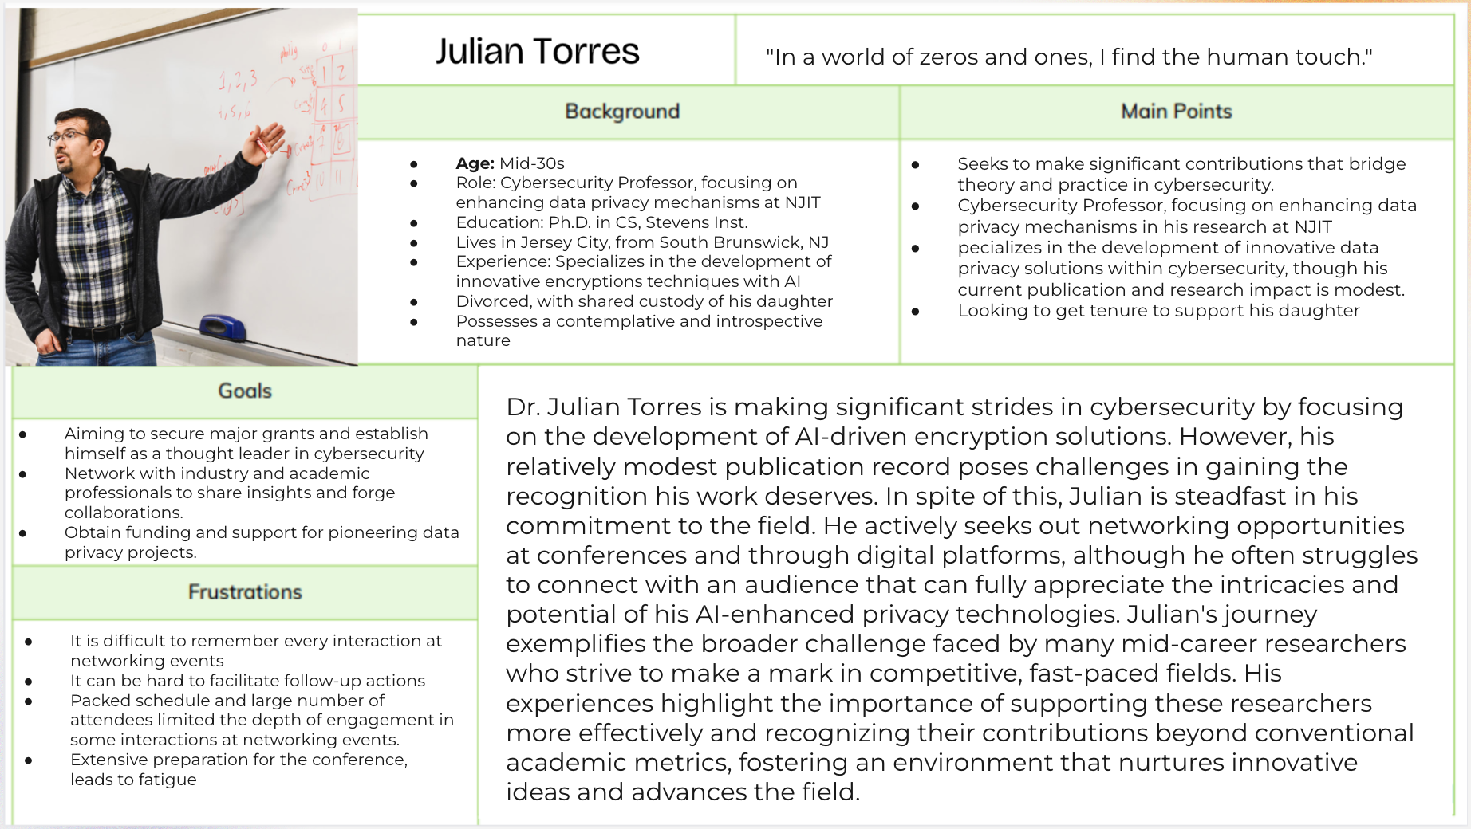

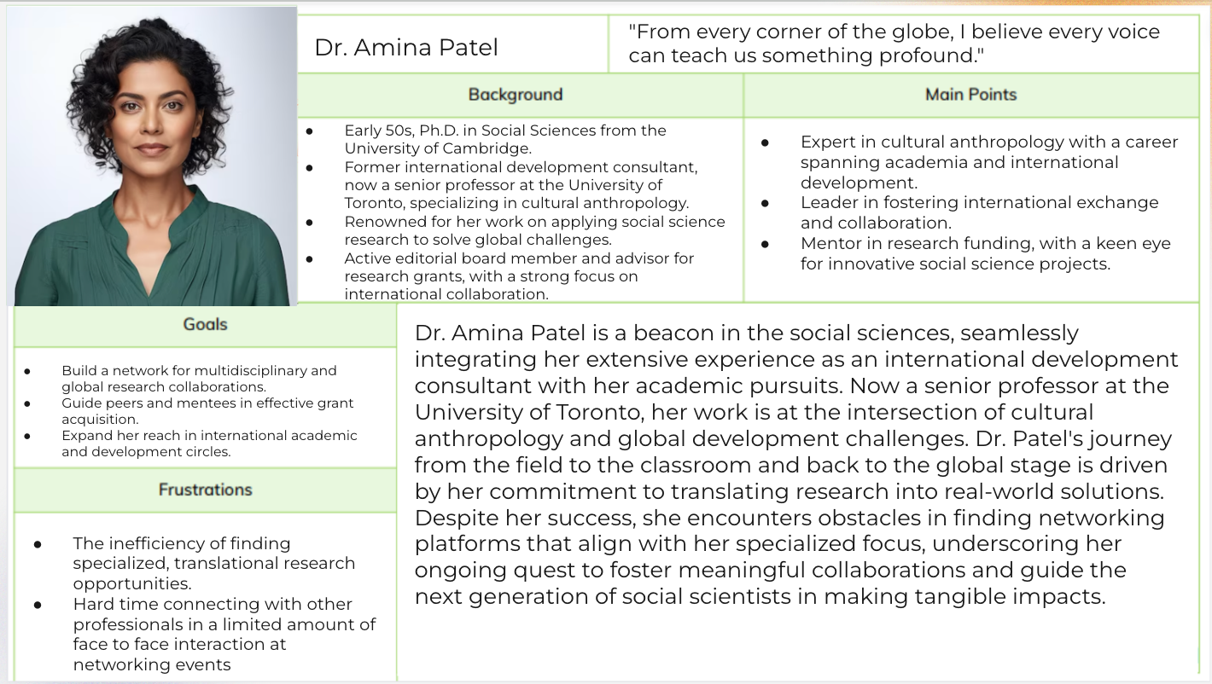

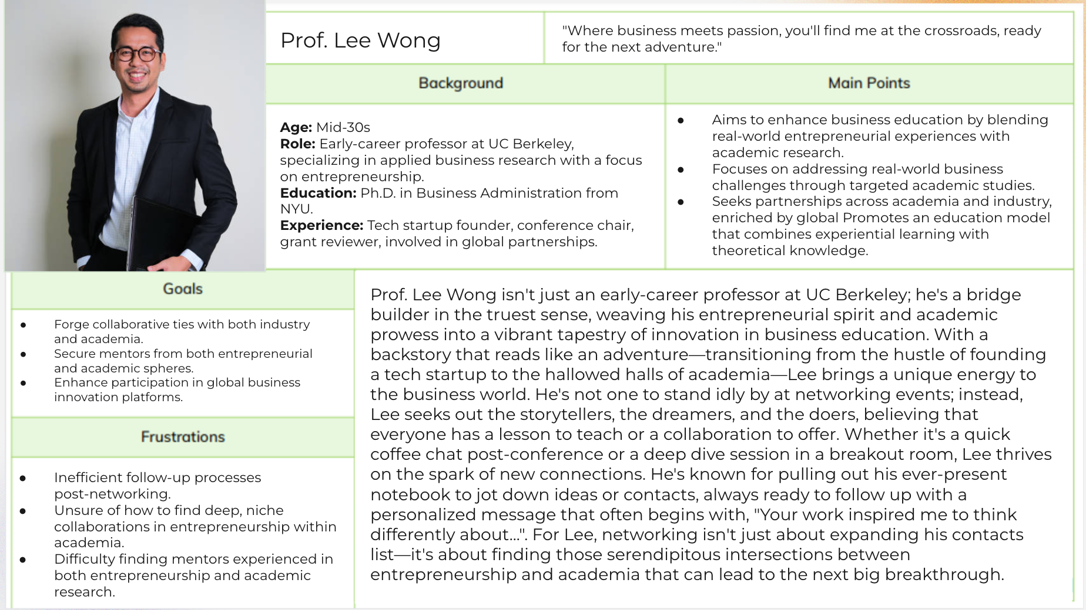

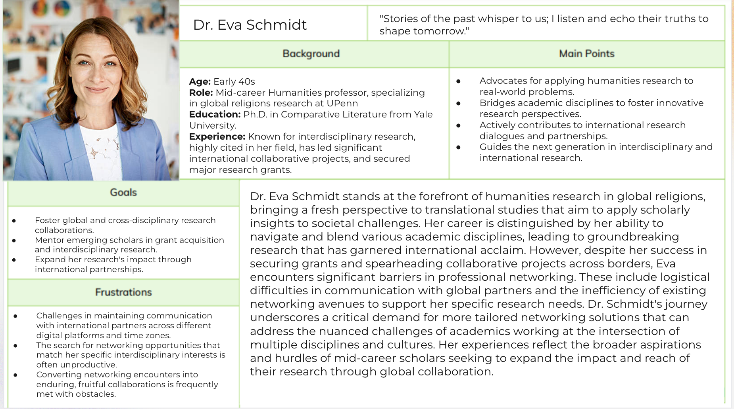

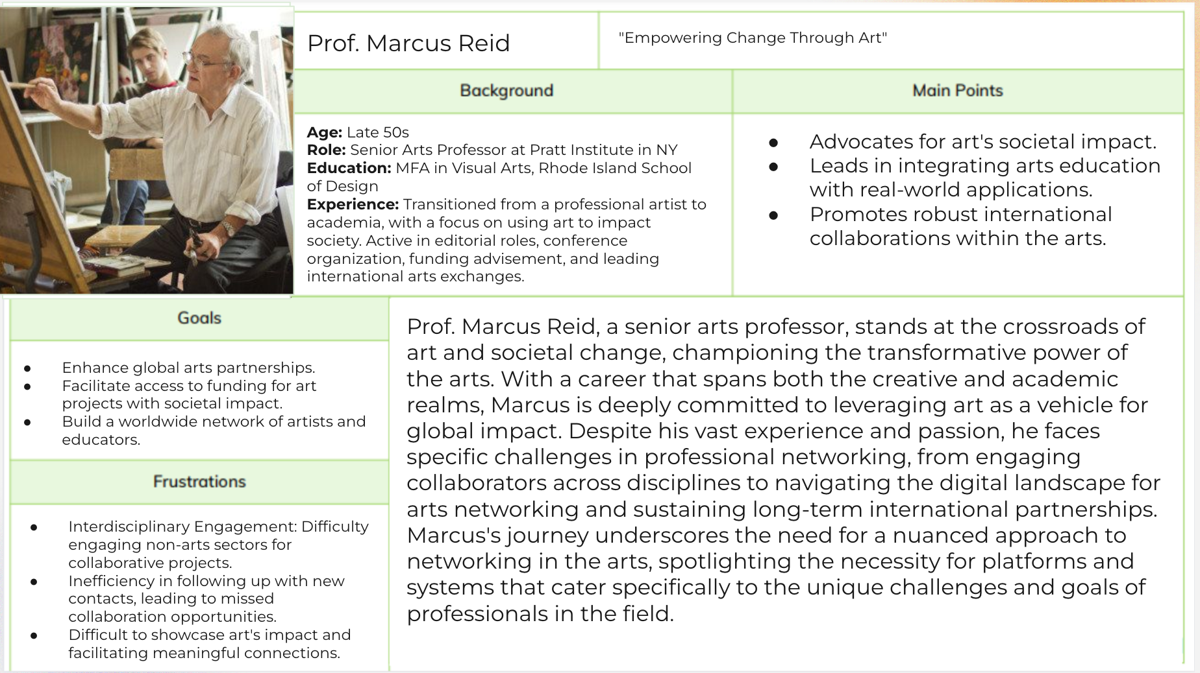

### Students

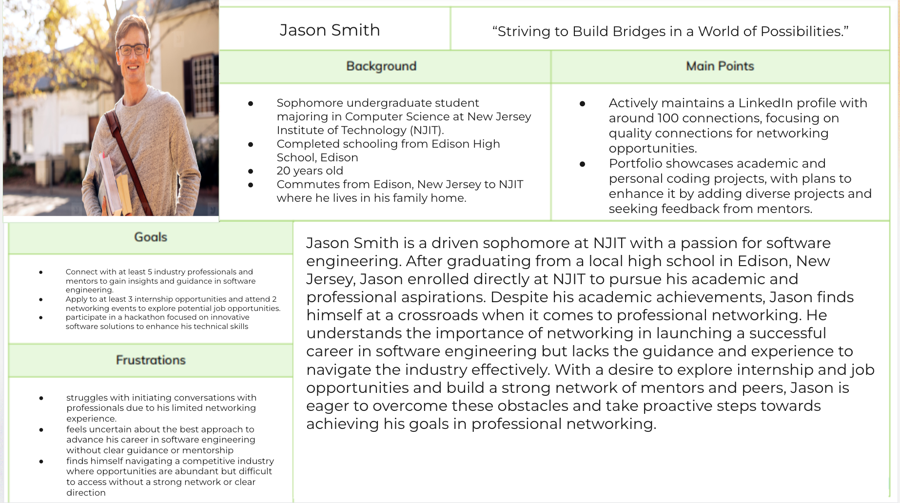

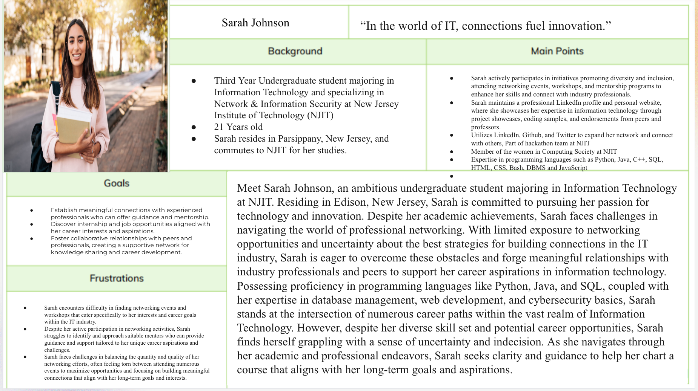

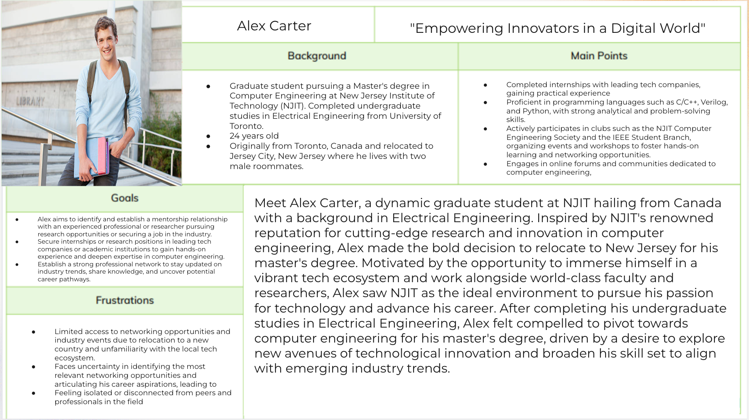

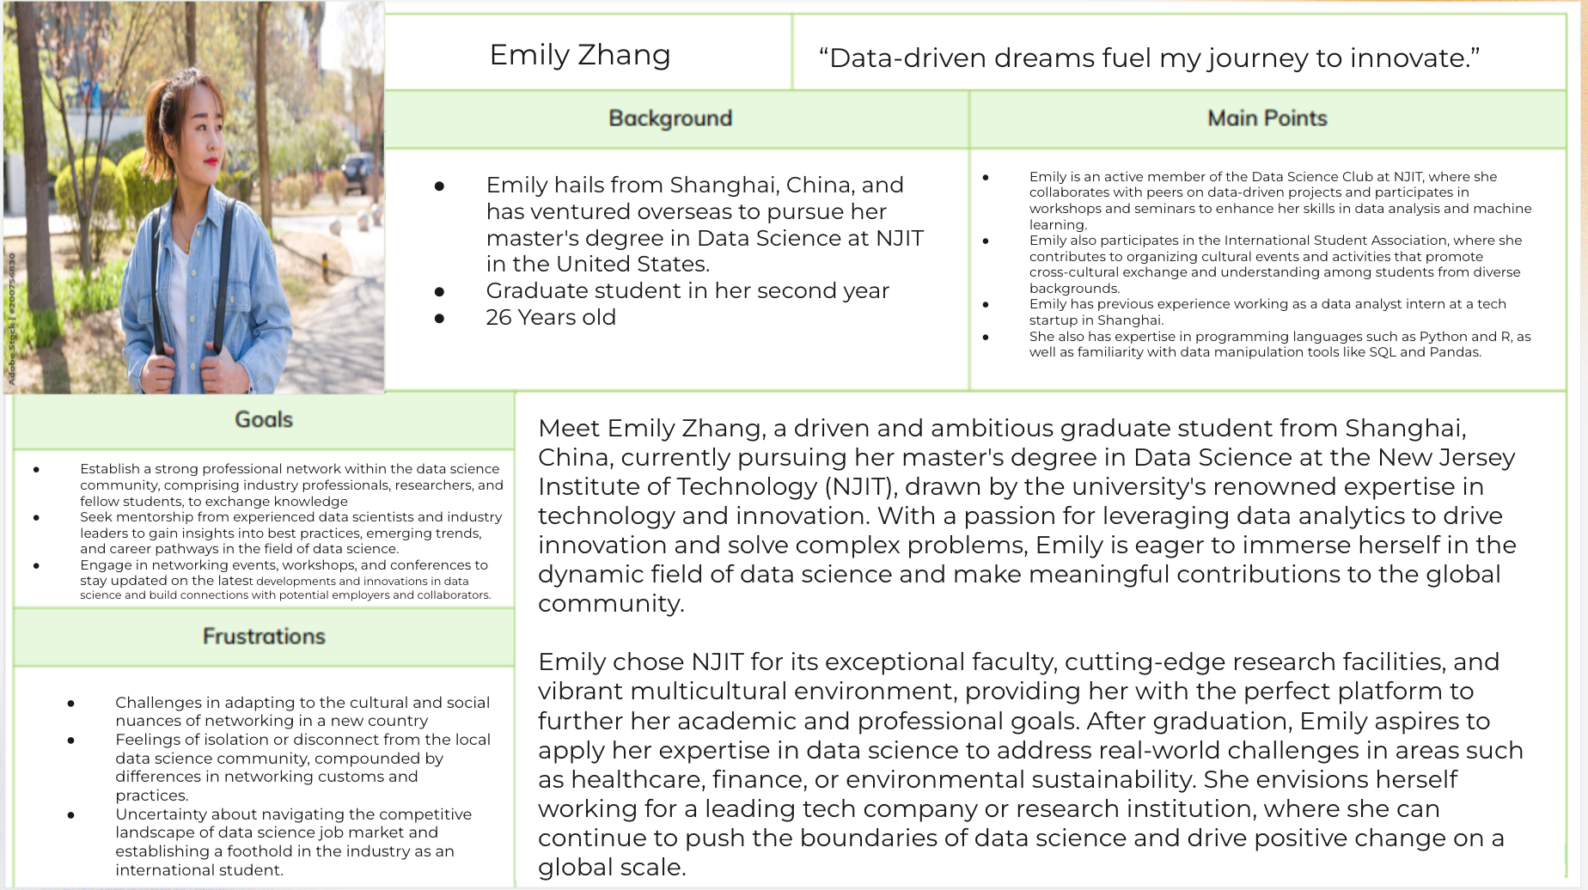

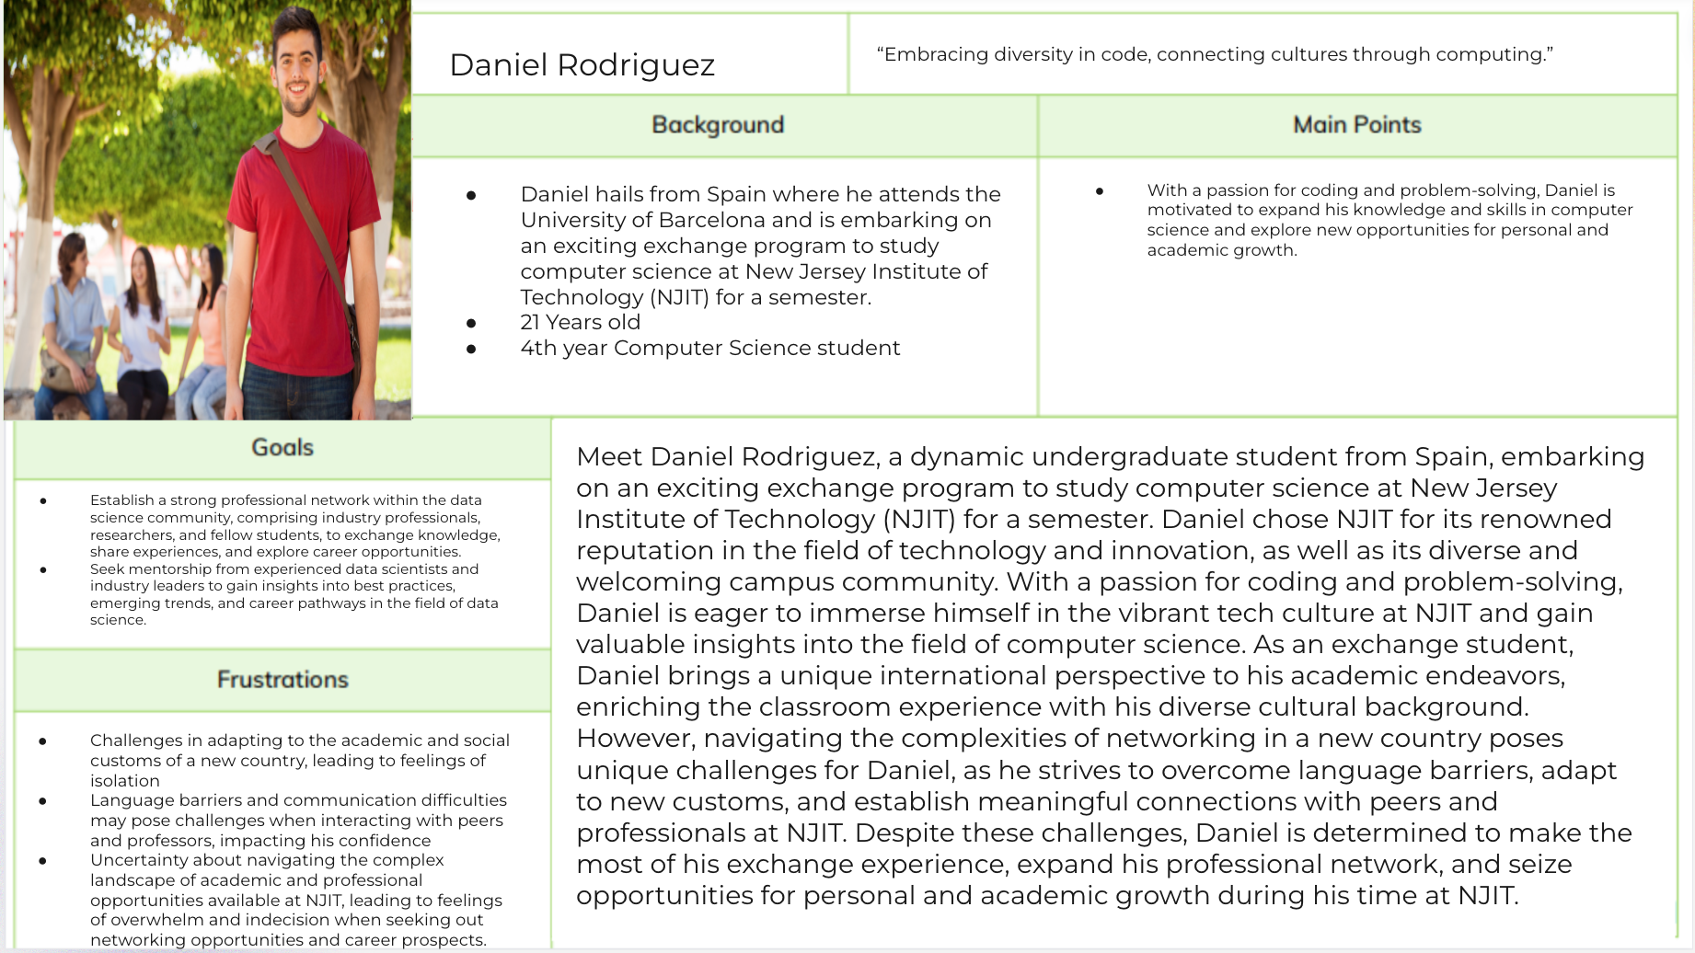

### Tech Entrepreneurs

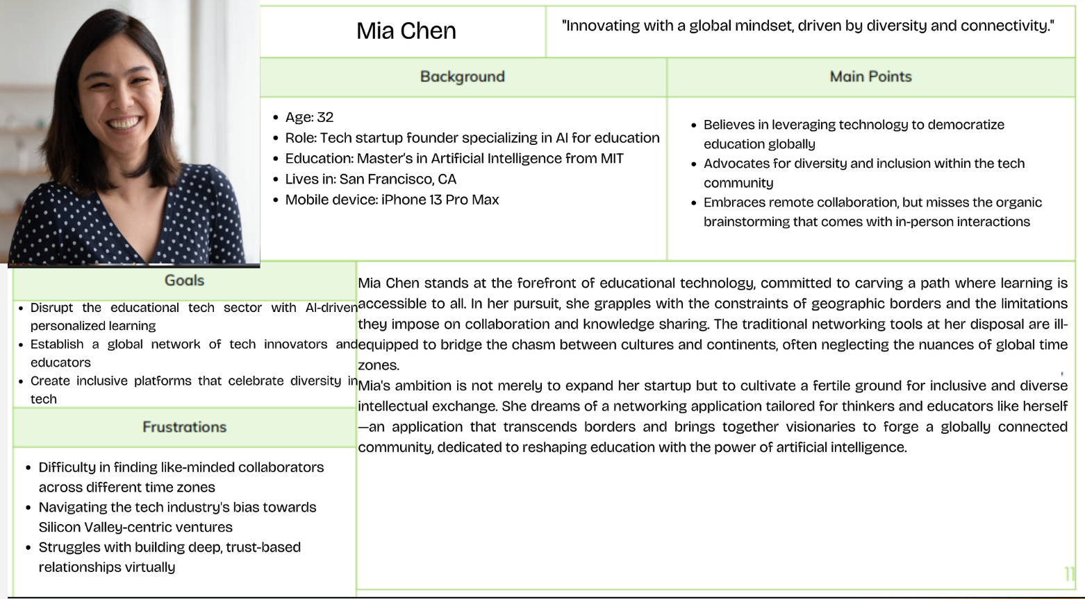

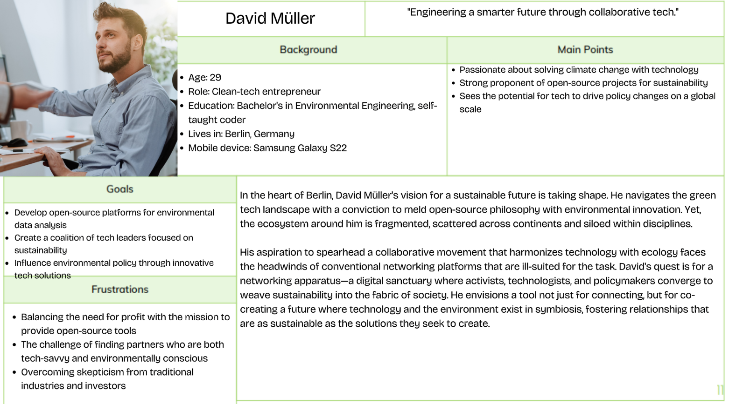

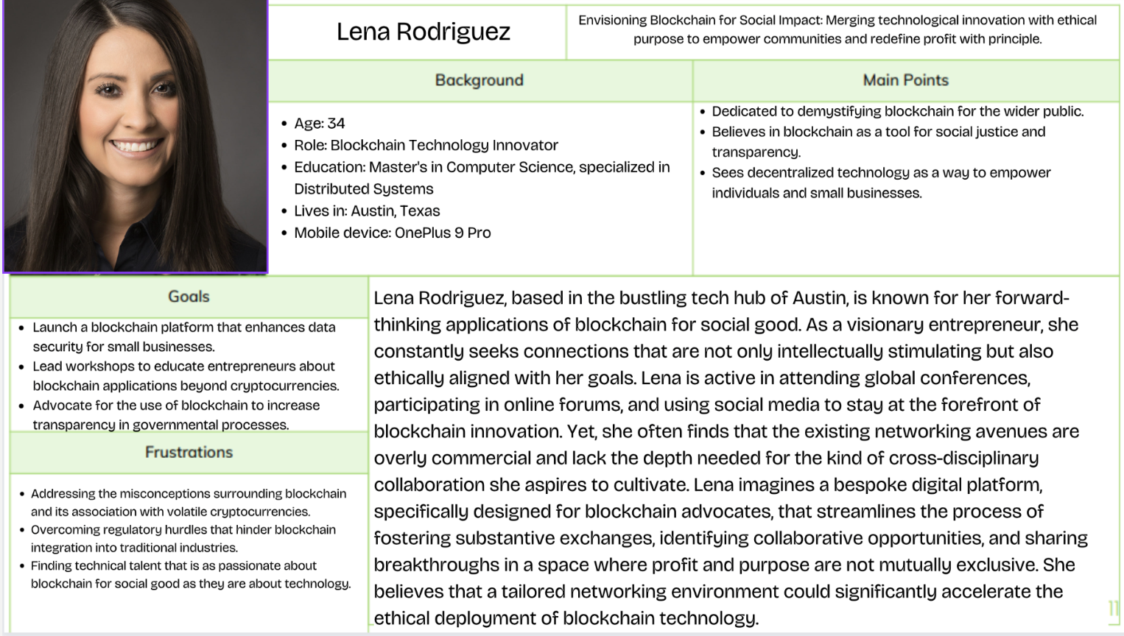

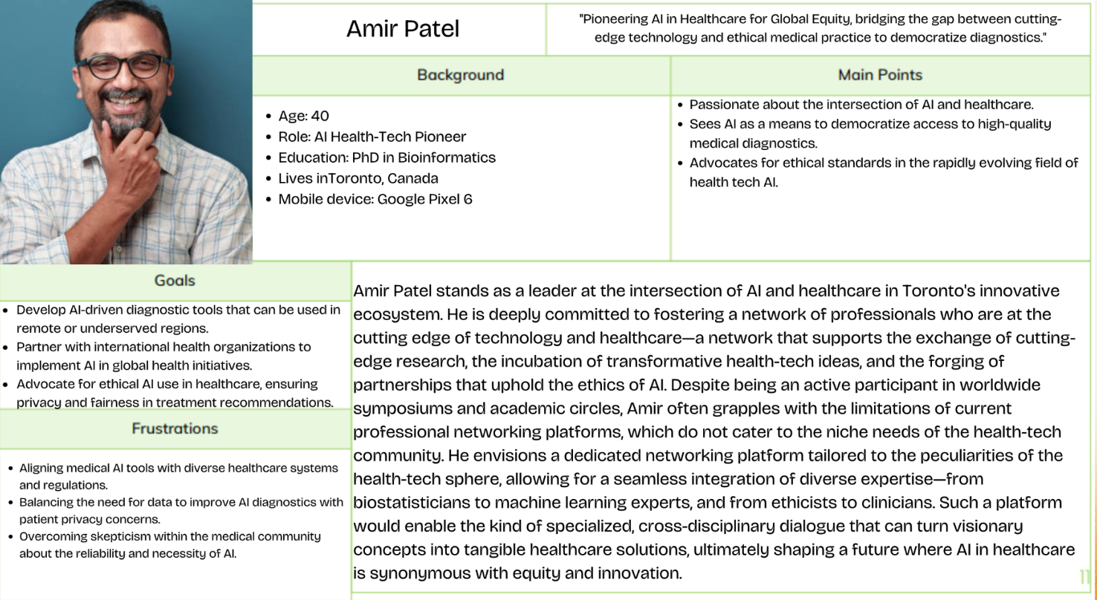

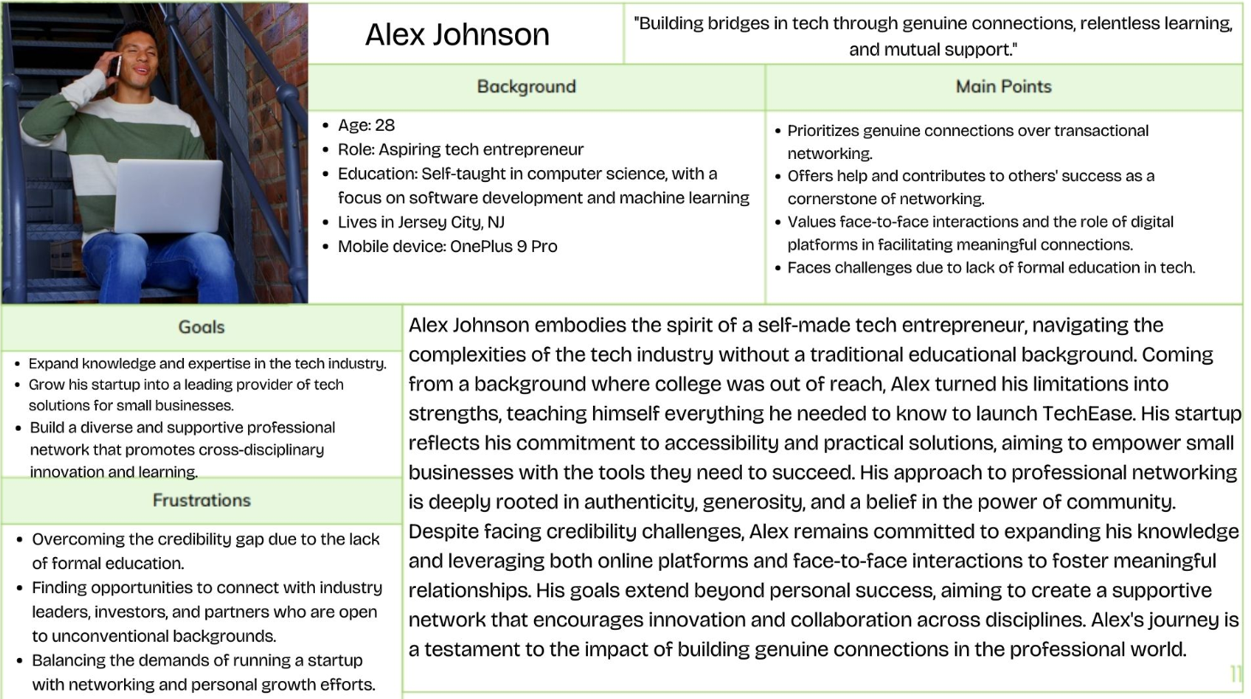

## Problem Scenario

[ChatGPT Link](https://chat.openai.com/share/3e7fbd48-319d-4d65-9a0e-5b4da9b89109)

### Professor



**Part 1: Call for Papers Submission**

* On December 1, 2023, Julian discovers a call for papers for ACM CCS 2024 while searching for prestigious cybersecurity conferences where he can contribute his latest research. Motivated by the opportunity to share his findings on blockchain vulnerabilities, he meticulously prepares and submits a detailed paper, hoping it will be accepted for presentation. The paper is titled "Unveiling Achilles: A Comprehensive Analysis of Vulnerabilities in Blockchain Technology".



**Part 2: Paper Acceptance and Initial Preparations**

* Several months later, Julian receives the good news: his paper has been accepted for presentation at ACM CCS 2024. Thrilled by this opportunity, he begins to plan not only his presentation but also how he can maximize his attendance by networking with peers and industry leaders. He marks his calendar for October 14-18, 2024, in Salt Lake City, and starts outlining his approach for the conference. Julian compares flight options, ultimately booking a flight from Newark Liberty International Airport, which is the most convenient airport from NJIT. He also reserves a hotel close to the conference venue in Salt Lake City to minimize travel time each day.



**Part 3: Researching Networking Opportunities**

* By mid-September 2024, Julian started to focus more on the networking aspect of the conference. He delves into the list of speakers and registered attendees provided by the conference organizers, identifying key figures in cybersecurity who have interests aligning with his own. He mentally plans some questions and discussion topics that will allow him to engage effectively with these experts.



**Part 4: Travel to the Conference**

* The day before the conference starts, Julian packs his presentation materials, ensuring all his electronic devices are charged and he has all necessary cables and backups for his presentation. He leaves NJIT in the early morning, catching a shuttle to the airport. His flight experiences a brief delay due to weather conditions, heightening his anxiety, but he uses the extra time at the airport to review his notes and mentally prepare for the days ahead. Upon arriving in Salt Lake City, Julian navigates the unfamiliar airport, collects his luggage without incident, and takes a taxi to his hotel. He checks in and spends the evening settling into his room, double-checking the functionality of his presentation on both his laptop and a USB drive. To combat his nerves and jet lag, he takes a short walk around the hotel area to familiarize himself with the route to the conference venue.



**Part 5: Final Preparations and Strategy Execution**

* In the days leading up to the conference, Julian finalizes his presentation materials for ACM CCS 2024. He creates engaging visuals for his talk on enhancing blockchain security, using diagrams and charts to clearly illustrate attack vectors and the effectiveness of his security measures. He revises his speech for clarity and accessibility, balancing technical depth to engage a diverse audience. Julian also refines his elevator pitch, practicing it repeatedly to ensure conciseness and impact. A practice session with his NJIT research group provides critical feedback, helping him perfect the flow and technical descriptions. Julian records his practice sessions to refine his delivery and ensure he projects confidence and expertise.

**Conference Day 1:**



**Part 6: Conference Arrival and Initial Observations**

* Julian arrived at the ACM CCS 2024 venue in Salt Lake City on the morning of October 14, 2024, at 8:00 AM. As he enters the bustling conference environment, he collects his badge, grabs a program, and uses his digital tablet to highlight sessions and identify key speakers, particularly those focusing on cloud data security and encryption.



**Part 7: Delivering the Presentation**

* At 11:35 AM, Julian proceeds to the designated room to set up for his presentation. He ensures all technical equipment works properly, double-checks his slides, and tests the microphone. As attendees begin to fill the room, Julian greets them, trying to create a welcoming atmosphere. He delivers his presentation with clarity, effectively using his visuals to highlight key points about blockchain vulnerabilities and proposed security enhancements. The presentation concludes with a Q&A session, where Julian thoughtfully addresses the audience's inquiries.



**Part 8: Engaging with Dr. Sarah Chen**

* On October 15, 2024, at 11:00 AM, during the second day of ACM CCS 2024, Julian, still buoyed by the successful presentation the previous day, encountered Dr. Sarah Chen among the bustling attendees. Eager to discuss more about contemporary encryption challenges, Julian introduces himself with genuine admiration for her work. Dr. Chen, approachable and insightful, guides them to a quieter spot where they can converse without the surrounding noise.
* Their conversation quickly deepens, exploring nuanced aspects of encryption in today's cybersecurity landscape. Dr. Chen shares from her vast experience, recounting challenges and breakthroughs she has encountered. Julian, keen to absorb as much as he can, discusses his recent research findings and theoretical approaches. Amid their exchange, Julian finds himself struggling to juggle active engagement and note-taking, realizing the need for more practical note-taking solutions in such settings. They exchange contact information, promising to keep in touch for potential future collaborations, and Julian notes Dr. Chen’s engaging manner and slight accent, which adds a memorable touch to their interaction.



**Part 9: Journey Home**

* At 8:00pm , exhausted but fulfilled after a long day of presentations and discussions, Julian makes his way back to the hotel to collect his luggage. The day’s activities, coupled with the travel and social interactions, have taken their toll, leaving him looking forward to a quiet flight home to decompress and organize his thoughts.
* Julian catches a late evening flight from Salt Lake City to Newark. Settled in his seat, he attempts to sort through his conference notes but finds himself too tired to focus. Instead, he reclines his seat slightly and reflects on the day's events, mentally replaying the discussions and planning follow-up actions in a more relaxed manner. He drafts a few reminder emails in his phone’s notes app, intending to send them once he’s rested and has a clear mind.
* Upon landing in Newark, Julian navigates the familiar airport with a sense of relief. He retrieves his luggage, which thankfully arrives without delay, and heads for the airport shuttle, eager to get home and rest. As he sits back during the ride home, he thinks about the potential collaborations he discussed with Priya and others, excited about the possibilities but grateful for the upcoming opportunity to rest and recharge before diving back into his work.



**Part 10: Sorting Contacts and Connections (Julian’s Desk at NJIT- October 17, 2024 10:00 AM )**

* After returning from ACM CCS 2024, Julian faced the mundane task of organizing a messy stack of business cards, many of which were hastily collected during brief encounters at the conference. As he sifted through the cards, he realized that some were incomplete and one was missing altogether, leaving him unable to recall the contact's details. He decided to prioritize the contacts he remembered most clearly, choosing a few key individuals for follow-up. Julian manually entered their details into a simple spreadsheet and made LinkedIn connections where possible, adding a personal note to each request to remind the contact of their meeting. For those he couldn't find on LinkedIn, he set reminders to send emails. During this process, Julian also checked his LinkedIn for new connections and messages, reviewing profiles of those he had exchanged digital info with at the conference. This allowed him to add a layer of interaction history to his spreadsheet, which helped compensate for the missing card by relying on LinkedIn’s detailed profiles.



**Part 11: Immediate Follow-Up with Dr. Sarah Chen (October 20, 2024 4:00 PM, Julian’s Desk at NJIT)**

* Julian sends an appreciative follow-up email to Dr. Sarah Chen just six days after the ACM CCS 2024 conference, on October 20, 2024. He thanks her for the enriching discussion during their panel and proposes a collaborative project that would tackle encryption vulnerabilities in emerging technologies. Julian outlines a preliminary research framework, suggests possible funding sources, and proposes a timeline for submitting their grant proposal. He carefully crafts his email to foster a collaborative spirit and a sense of shared mission.



**Part 12: Follow-Up Email to Dr. Sarah Chen (November 15, 2024)**

* Following up on their initial conversation, Julian sends another email to Dr. Sarah Chen on November 15, 2024. He provides additional details on the collaborative project they discussed, including potential methodologies and research objectives. Julian expresses his eagerness to begin working together and suggests scheduling a follow-up meeting to further refine their research framework.

### Student

[ChatGPT Link](https://chat.openai.com/share/686ca662-51aa-404b-9563-09a94d09a32d)

Semester: Fall 2023

**What: Sarah attends the NJIT Orientation Week events.**

August 28, 2023 - Orientation Week:

Morning:

Who: Sarah Johnson

Where: NJIT campus, Newark, New Jersey

When: 9:00 AM - 12:00 PM

Description: Sarah begins her day by attending the NJIT welcome session in the Campus Center auditorium at 9:00 AM. She listens to speeches from university administrators and learns about the history and mission of NJIT. After the welcome session, Sarah joins a campus tour led by student ambassadors, exploring key buildings and facilities such as the library, computer labs, and student center.



**What: Sarah attends the IT Club's welcome meeting.**

Who: Sarah Johnson, IT Club Members

Where: Campus Meeting Room

When: 2:00 PM - 4:00 PM

Description: Sarah joins the IT Club's welcome meeting in the Campus Center meeting room at 2:00 PM. She meets the club president, Emily Chen, and other members, learning about upcoming events and initiatives aimed at supporting students interested in information technology. Sarah volunteers to help organize a coding workshop scheduled for September.

Networking Intent: Sarah connects with Emily Chen, the club president, with the intention of getting involved in the IT Club's activities and networking with other students interested in information technology. She shares her enthusiasm for coding and software development and exchanges contact information with Alex to stay updated on future events and opportunities.



**What: Sarah explores campus resources during the resource fair.**

Who: Sarah Johnson, Campus Resource Representatives

Where: Various Locations on Campus

When: 4:30 PM - 6:00 PM

Description: Sarah visits the resource fair held in the Campus Center atrium. She stops by booths representing IT-related student clubs, coding bootcamps, internship programs, and software development workshops. Sarah collects informational brochures, chats with representatives, and signs up for newsletters to stay updated on IT-related campus events and opportunities.

Networking Intent: Sarah interacts with representatives from IT-related student clubs and career development programs to gather information about coding workshops, internship opportunities, and software development resources. She exchanges contact information with representatives from the Career Development Center and expresses her interest in attending IT-focused networking events and workshops to enhance her coding skills and career prospects.



**What: Sarah attends a Women in STEM club meeting.**

Who: Sarah Johnson, Members of the Women in STEM Club

Where: Campus Meeting Room

When: 2:00 PM - 4:00 PM, September 15, 2023

Description: Sarah arrives at the designated campus meeting room for the Women in STEM club meeting at 2:00 PM. She greets fellow members warmly and takes a seat among her peers. The meeting begins with a welcome from the club president, Emily Parker, who shares the agenda for the day. Sarah actively participates in discussions about upcoming events and initiatives aimed at supporting women in technology fields. She listens attentively as members propose ideas for guest speakers, workshops, and community outreach projects. Sarah volunteers to help organize an upcoming networking event designed to connect club members with industry professionals. She offers her assistance in coordinating logistics, promoting the event, and securing guest speakers. Additionally, Sarah signs up for the club's mentorship program, expressing her interest in being paired with a mentor who can provide guidance and support as she navigates her academic and professional journey in STEM.

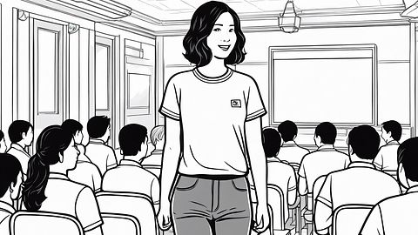

**What: Sarah attends a networking mixer organized by the IT department.**

Who: Sarah Johnson, IT Students, Industry Professionals

Where: NJIT campus, Newark, New Jersey

When: 5:30 PM - 8:00 PM, September 20, 2023

Description: Sarah arrives at the networking mixer on NJIT campus at 5:30 PM, feeling excited and eager to meet industry professionals and expand her network. She registers at the check-in table, receives a name tag, and enters the event space filled with fellow IT students and industry representatives. Sarah approaches the networking area, where she sees booths set up by various companies and organizations. She starts engaging in conversations with alumni, recruiters, and professionals from different companies, introducing herself confidently and expressing her interest in learning more about their roles and experiences in the industry. Sarah exchanges contact information with several professionals, discussing potential internship opportunities, and expressing her enthusiasm for contributing to their organizations.



**What: Sarah attends a database management workshop.**

Who: Sarah Johnson, Professor, Classmates

Where: Classroom, NJIT campus, Newark, New Jersey

When: 9:00 AM - 12:00 PM, October 5, 2023

Description: Sarah arrives at the classroom for the database management workshop promptly at 9:00 AM. The workshop is led by her database management professor, Dr. Rodriguez, who introduces the agenda for the session. Sarah takes her seat among her classmates, eager to enhance her understanding of database management concepts and practical skills. Throughout the workshop, she actively participates in discussions, asking insightful questions and sharing her perspectives on various topics. Sarah collaborates with her classmates on hands-on exercises, working together to solve problems and apply theoretical concepts to real-world scenarios. She engages in group discussions, exchanging ideas and solutions with her peers, and offers assistance to classmates who may be struggling with certain concepts.



**What: Sarah participates in a coding bootcamp.**

Who: Sarah Johnson, Coding Bootcamp Instructors, Participants

Where: Tech Incubator Space, Newark, New Jersey

When: 9:00 AM - 12:00 PM, October 15, 2023

Description: Sarah arrives at the Tech Incubator Space bright and early at 9:00 AM for the coding bootcamp. The morning session begins with introductions and an overview of the day's agenda by the bootcamp instructors. Sarah joins her fellow participants in diving into advanced programming languages and techniques, tackling challenging coding exercises and projects. She actively engages in group discussions, sharing her insights and strategies with her peers. Sarah collaborates with other participants on coding challenges, exchanging ideas and brainstorming solutions together. Throughout the morning, she receives personalized feedback and guidance from the instructors, helping her to refine her coding skills and deepen her understanding of complex programming concepts.



**What: Afternoon Coding Sessions and Projects**

Who: Sarah Johnson, Coding Bootcamp Instructors, Participants

Where: Tech Incubator Space, Newark, New Jersey

What: Afternoon Coding Sessions and Projects

When: 1:00 PM - 5:00 PM, October 15, 2023

Description: After lunch, Sarah returns to the coding bootcamp for the afternoon sessions and projects. The instructors dive deeper into advanced coding topics, leading interactive lectures and hands-on coding exercises. Sarah continues to collaborate with her peers, working together to solve complex programming challenges and complete group projects. She actively seeks clarification from the instructors on any areas of confusion, demonstrating her commitment to mastering the material. Throughout the afternoon, Sarah remains focused and engaged, leveraging the opportunity to expand her coding skills and build her portfolio with real-world projects.



**What: Hackathon Registration and Kickoff**

Who: Sarah Johnson

Where: NJIT campus, Newark, New Jersey

When: 10:30 AM - 11:00 AM, November 10, 2023

Description: Sarah arrives on campus at 10:30 AM, ready to dive into the hackathon excitement. She heads to the registration area, where she checks in and receives her official hackathon badge and event swag. Sarah joins the other participants in the main auditorium for the hackathon kickoff ceremony, where event organizers welcome everyone and announce the weekend's schedule, themes, and rules. Sarah listens attentively, feeling a surge of excitement and determination as the hackathon officially begins.



**What: Prototyping and Coding Sprint**

Who: Sarah Johnson, Hackathon Team Members

Where: Hackathon Workspace, NJIT campus

When: 1:00 PM - 7:00 PM, November 10, 2023

Description: With their project concept solidified, Sarah and her team dive into a marathon coding session. They work tirelessly throughout the afternoon and into the evening, transforming their ideas into a functional prototype. Sarah takes on various coding tasks, leveraging her programming skills to develop key features and functionalities. As they encounter challenges and roadblocks, the team collaborates closely, troubleshooting together and finding creative solutions. Despite the intensity of the coding sprint, Sarah and her teammates remain focused and motivated, fueled by their shared passion for innovation and technology.



**What: Final Preparations and Rehearsals**

Who: Sarah Johnson, Hackathon Team Members

Where:GITC 1100, NJIT campus

When: 8:00 AM - 10:00 AM, November 12, 2023

Description: Sunday morning marks the final stretch of the hackathon weekend, and Sarah and her team are determined to make it count. They gather at their workspace early in the morning, putting the finishing touches on their project and rehearsing their presentation. Sarah ensures that the presentation slides are polished, the script is perfected, and each team member knows their role in the pitch. They run through the presentation multiple times, refining their delivery and addressing any last-minute concerns or questions.



**What: Networking Webinar**

When: 6:00 PM - 8:00 PM

Description: Sarah eagerly participates in the networking webinar, engaging with guest speakers, fellow attendees, and industry experts throughout the event. She listens attentively to the presentations and panel discussions, taking detailed notes on key insights, trends, and best practices shared by the speakers. During the Q&A session, Sarah seizes the opportunity to ask thoughtful questions, seeking clarification and additional information on topics relevant to her career interests. She also actively participates in the networking activities facilitated by the webinar platform, connecting with other attendees through virtual chat rooms, discussion forums, and networking lounges. Sarah exchanges contact information, LinkedIn profiles, and professional insights with peers and industry professionals, laying the groundwork for future collaborations and networking opportunities.

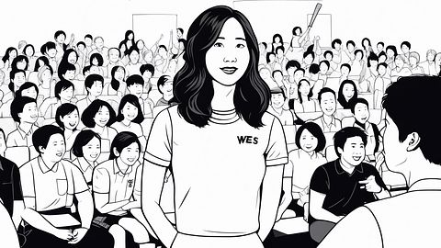

**What: Feedback and Reflection**

When: 3:00 PM - 4:00 PM, December 10, 2023

Description: After the presentations conclude, Sarah and her classmates engage in a feedback session facilitated by their professor. Sarah receives positive feedback on her presentation, with her professor commending her thorough research, clear communication, and innovative approach to the project. She listens attentively to feedback from her peers, taking note of areas for improvement and opportunities for future growth. As the session wraps up, Sarah reflects on her end-of-semester project experience, feeling proud of her accomplishments and grateful for the support and encouragement of her classmates and professor.



### Tech Entrepreneur

Mia Chen’s Networking: A Detailed Scenario

Background

Mia Chen is a tech startup founder specializing in AI for personalized learning within the EdTech field, based in San Francisco. With a Master's in Artificial Intelligence from MIT, Mia is leading her startup with an ambition to disrupt the educational tech sector. Despite her technical prowess and innovative ideas, Mia struggles with finding like-minded collaborators, navigating the tech industry's bias towards Silicon Valley-centric ventures, and building trust-based relationships virtually. She recognizes the potential of an upcoming EdTech conference to establish her presence, connect with global educators, and foster partnerships for her AI-driven personalized learning initiatives.

**October 2024: Setting the Stage for Success**



**Goal Setting Session**

Who: Mia Chen

What: Determines ambitious networking goals for the conference

When: October 1, 2024, 2:00 PM

Where: San Francisco, Mia's Startup Office

Mia Chen gathers her startup team at their San Francisco office to strategize for the upcoming technology conference. In this session, Mia emphasizes her goal to use the conference as a platform to spotlight their company's innovative applications of AI in education. The team discusses various aspects of their technology, preparing to engage conference attendees with demonstrations and discussions that highlight the impact of their solutions on educational practices. Mia outlines the key targets for networking: potential investors interested in EdTech, educators open to integrating new technologies, and other innovators in the field.



**Identifying Conference Opportunities**

Who: Mia Chen

What: Carefully selects sessions and workshops relevant to her startup's mission

When: October 10, 2024, Late Afternoon

Where: San Francisco, Mia's Startup Office

In the quiet of a late afternoon at her startup office in San Francisco, Mia Chen meticulously reviews the upcoming technology conference's schedule. Her goal is to strategically select sessions that align closely with her startup’s mission to innovate in the field of AI-driven educational technology. Mia focuses on pinpointing keynotes, panels, and workshops where thought leaders and decision-makers in the EdTech space will discuss current trends, challenges, and opportunities. She prioritizes sessions that not only align with her startup’s goals but also offer the potential for direct engagement with industry influencers who could become collaborators or mentors. Mia takes detailed notes on each selected session, planning her days at the conference to maximize learning and networking opportunities, ensuring she is present at discussions that are most likely to impact her startup’s trajectory.



**Mentor Consultation for Strategic Networking**

Who: Mia Chen and her Mentor

What: Seeks guidance on maximizing conference opportunities

When: October 15, 2024, 11:00 AM

Where: Video Call from Mia's Startup Office

Mia Chen settles into her startup office for a pivotal video call with her mentor scheduled for mid-morning. The purpose of the call is to refine her approach to the upcoming technology conference, ensuring she effectively capitalizes on the networking opportunities it presents. Mia shares her plans to showcase her startup’s innovative AI applications in education, seeking her mentor’s advice on how to articulate her vision compellingly and engage meaningfully with key stakeholders. Her mentor, an experienced figure in the EdTech industry, provides insights on strategic networking, emphasizing the importance of targeted interactions and the impact of a well-crafted pitch. They go over the list of sessions Mia has chosen, with the mentor suggesting additional ways to connect with influencers and decision-makers. The conversation also covers techniques for following up post-conference to maintain the connections she establishes, reinforcing the advice with anecdotes and examples from their own extensive experience.

**November 2024: Immersion in the EdTech Conference**



**Crafting an Impactful Narrative**

Who: Mia Chen

What: Hones her startup's story and presentation for the conference

When: November 5, 2024, Evening

Where: San Francisco, Mia's Startup Office

Late in the evening at her startup office in San Francisco, Mia Chen dedicates time to perfecting her startup’s narrative. With the upcoming technology conference looming, Mia is focused on honing a compelling story that encapsulates the essence and value of her company’s AI-driven approach to personalized learning. She meticulously crafts her presentation slides, integrating engaging visuals and data-driven evidence to demonstrate the effectiveness and innovative nature of her educational solutions. The preparation involves refining key talking points that illustrate how her startup addresses specific educational challenges through technology, ensuring that the narrative is both persuasive and relatable for her audience. This session is crucial for Mia as she aims to not just inform but also inspire conference attendees, making them see the transformative potential of her products in the education sector.



**Conference Kick-off and Personal Branding**

Who: Mia Chen

What: Initiates her conference journey with a focus on branding

When: November 10, 2024, Morning

Where: EdTech Conference, Los Angeles, CA

Mia Chen starts her day at the bustling EdTech Conference in Los Angeles with a clear focus on branding. Upon arrival, she ensures every element of her presence—from her professional yet approachable attire to her meticulously designed business cards—reflects the innovative spirit of her startup. Mia's introductory pitches are carefully rehearsed, embedding the core values and mission of her company in every conversation to make a memorable first impression. This strategic approach to personal branding is geared towards establishing her as a thought leader in AI-driven education, setting a solid foundation for the valuable connections she plans to forge throughout the event. Her preparation and attention to detail underscore her commitment to not only sharing her vision but also engaging effectively with potential partners, investors, and peers in the industry.



**Navigating Sessions and Workshops**

Who: Mia Chen

What: Actively participates in sessions, asking poignant questions

When: November 10, 2024, Throughout the Day

Where: EdTech Conference, Various Locations

Throughout the day at the EdTech Conference, Mia Chen is a dynamic presence in various sessions and panel discussions. She actively engages with speakers and fellow attendees, asking insightful and thought-provoking questions that highlight her deep understanding of AI in education and her startup's innovative vision. These interactions are not only a showcase of her expertise but also serve as strategic moves to draw attention to her startup's unique approach to personalized learning solutions. By deliberately choosing sessions that align with her company's goals, Mia uses each opportunity to scout for potential collaborations, laying the groundwork for future partnerships that could enhance her startup’s offerings and market reach. Her questions often spark further discussions during breaks, allowing her to deepen connections with industry leaders and potential investors interested in her field.



**Connecting with Jacob Kim at a Panel Discussion**

Who: Mia Chen and Jacob Kim

What: Engages with a panelist post-discussion

When: November 11, 2024, Late Morning

Where: EdTech Conference, Panel Discussion Room

After attending a compelling panel discussion on AI ethics in education, Mia Chen approaches one of the panelists, Jacob Kim, at the conclusion of the session. She expresses her admiration for his thorough and thoughtful insights, particularly his perspective on the ethical considerations crucial to AI development in the educational sector. Seizing this opportunity, Mia introduces her startup, which focuses on developing ethical AI solutions for learning environments. She shares brief highlights of her work, emphasizing how her company aligns with the ethical standards discussed. This exchange sparks Jacob's interest, leading to a discussion about potential areas of synergy between their work. They exchange business cards and agree to explore potential collaborations, setting a foundation for future communications focused on mutual interests in promoting ethical AI practices in education.



**Exhibiting at the Startup Showcase**

Who: Mia Chen

What: Presents her startup at the showcase

When: November 11, 2024, Afternoon

Where: EdTech Conference, Startup Showcase Area

In the bustling atmosphere of the EdTech Conference's Startup Showcase Area, Mia Chen takes the stage to present her innovative startup. Her presentation, rich with engaging visuals and compelling data, effectively outlines her company’s use of AI to enhance educational experiences. As Mia delves into how her startup integrates ethical AI practices to personalize learning, her enthusiasm and clear vision capture the attention of a diverse audience. The detailed examples of her platform’s impact in real-world educational settings resonate with the attendees, sparking immediate interest. Following her presentation, several attendees approach Mia, eager to discuss how her solutions could align with their needs. These conversations open doors to potential partnerships and investment opportunities, significantly amplifying her startup’s visibility and opening up avenues for future collaboration and growth.



**Building Rapport with Investors at Roundtable Discussions**

Who: Mia Chen

What: Connects with investors during focused discussions

When: November 11, 2024, Evening

Where: EdTech Conference, Roundtable Discussion Room

As the day draws to a close at the EdTech Conference, Mia Chen participates in a series of roundtable discussions specifically designed for entrepreneurs and investors. Positioned in the roundtable discussion room, Mia adeptly communicates the potential and scalability of her startup, which specializes in AI-driven educational solutions. She succinctly explains her technology’s unique advantages, its market readiness, and the strategic plan for scaling operations. Her presentation is not only informative but also persuasive, highlighting the significant impact her startup can have on modernizing education. This focused approach, coupled with her clear articulation of the startup's vision and potential returns, successfully captures the attention of investors who specialize in EdTech ventures. By the end of the discussions, several investors express interest in scheduling private meetings to explore investment opportunities with Mia’s startup, recognizing the tangible value and innovation she brings to the educational technology landscape.



**Networking Mixer: Diverse Connections**

Who: Mia Chen and Various Attendees

What: Meets a spectrum of professionals at a casual networking event

When: November 12, 2024, Evening

Where: EdTech Conference, Networking Mixer

Mia joins the mixer, engaging in discussions that extend beyond immediate business interests to foster a sense of community and shared purpose within the EdTech field.

**December 2024:**



**Collaboration Proposal to Jacob Kim**

Who: Mia Chen to Jacob Kim

What: Proposes a collaboration that aligns with their shared vision

When: December 5, 2024, Morning

Where: Email Communication

Mia reaches out to Jacob with a detailed proposal for collaboration on developing ethical AI guidelines for educational platforms, initiating a promising dialogue.



**Investor Follow-up Meetings**

Who: Mia Chen

What: Participates in virtual meetings with interested investors

When: December 12, 2024, Throughout the Day

Where: Video Calls from Mia's Startup Office

Post-conference, Mia conducts follow-up meetings with investors, discussing terms and exploring funding options for her startup's growth.



**Reflection and Strategic Planning for the Next Phase**

Who: Mia Chen

What: Reflects on her networking outcomes and strategies for future engagements

When: December 29, 2024, Late Afternoon

Where: San Francisco, Mia's Startup Office

**January 2024: Product Development and Team Expansion**



**Week 1-2: New Hiring Initiatives**

Who: Mia Chen, HR team

What: Recruitment of additional team members to support expanded operations.

Description: As her startup experiences significant growth, Mia initiates a hiring drive to expand her team. The focus is on recruiting skilled developers to enhance the technical capabilities of her AI-driven educational platform, a strategic marketing specialist to amplify brand presence, and customer support professionals to ensure high-quality user engagement and support. Mia works closely with the HR team to outline the ideal candidate profiles, emphasizing a blend of technical expertise and passion for educational innovation. Job fairs, online recruitment platforms, and industry networking events are leveraged to attract top talent.



**Week 3-4: Development of New Learning Modules**

Who: Mia Chen, product team

What: Development of new educational modules based on AI learning insights.

Description: Mia leads her product team in designing advanced educational modules that leverage AI to adapt dynamically to individual learning styles and paces. This initiative stems from user feedback and data analytics that indicated a need for more personalized learning experiences. The team prototypes several modules, including interactive AI tutors and predictive learning paths, integrating cutting-edge machine learning algorithms to enhance educational outcomes. Weekly progress meetings ensure the project remains on track and aligns with the company's educational goals.

**February 2024: Enhancing Brand Visibility and User Engagement**



**Month-Long: Marketing Campaign Launch**

Who: Mia Chen, marketing team

What: Launch of a new marketing campaign.

Description: With new products ready to hit the market, Mia and her marketing team launch an extensive campaign titled "Learning Personalized." This campaign utilizes multimedia channels including social media, online educational forums, and industry conferences to showcase how their platform personalized learning. Success stories from existing users and data-backed results are featured prominently. The campaign also includes customer testimonials and case studies that demonstrate the tangible benefits of the AI-driven learning platform. Influencer partnerships with educators and thought leaders in the tech and education sectors help increase reach and credibility.

**March 2024: Evaluating Impact and Planning Future Directions**



**Month-End Review:**

Who: Mia Chen, entire team

What: Quarterly business review and planning session.

Description: Mia convenes a quarterly business review with her entire team to assess the startup's performance against its Q1 goals and to strategize for the upcoming quarter. The session involves a deep dive into various aspects of the business, including product development progress, market penetration, user engagement metrics, and financial performance. Data-driven insights inform discussions on refining the product roadmap, potentially pivoting in response to emerging educational trends or technology advancements, and identifying key areas for investment. The meeting fosters a collaborative environment where team members are encouraged to contribute ideas and solutions, ensuring alignment and shared commitment to the company’s objectives.

## 

## Claims Analysis

[ChatGPT Link](https://chatgpt.com/share/6ffdf6ec-1a4a-471d-95d4-bd16ebf2d321?oai-dm=1)

[ChatGPT Link](https://chat.openai.com/share/6ffdf6ec-1a4a-471d-95d4-bd16ebf2d321)

### Professor

**Goal Setting Session**

* Description: Dr. Julian Torres outlines ambitious networking goals to connect his cybersecurity expertise with broader industry applications.
* Positive Aspects (+)
  + Clarity and Direction: Clear goals provide focus and motivation.
  + Professional Growth: Aims to elevate his profile and secure grants.
* Negative Aspects (−)
  + High Expectations: Ambitious goals may lead to pressure and disappointment if not met.
  + Resource Intensive: Requires significant time and effort to achieve.

**Researching Opportunities**

* Description: Julian filters through listings to find events aligned with his interests.
* Positive Aspects (+)
  + Targeted Approach: Focuses on relevant opportunities.
  + Efficient Planning: Helps prioritize potential engagements.
* Negative Aspects (−)
  + Time Consuming: Extensive research may detract from other duties.
  + Information Overload: Potential for overwhelm due to many options.

**Discovery Through Email**

* Details: Julian discovers the "Global Cybersecurity Advances Conference" through an email from an academic mailing list at NJIT.
* Positive Aspects (+)
  + Targeted Information Delivery: Relevant professional development opportunities./ Convenience: Easy access to conference information.
* Negative Aspects (−)
  + Information Overload: High volume of emails may lead to missed opportunities./ Passivity: Reliance on email might limit discovery.

**Mentor Meeting for Guidance**

* Description: Discussion on effective networking strategies with a senior colleague.
* Positive Aspects (+)
  + Expert Advice: Gains valuable insights.
  + Strategic Enhancement: Improves approach to networking.
* Negative Aspects (−)
  + Dependence on Others' Perspectives: May limit independent strategy development.
  + Time Required: Takes time from other tasks.

**Exploring Keynote Speakers and Sessions**

* Description: Reviews speakers and sessions for potential collaborations.
* Positive Aspects (+)
  + Prepared Engagement: Ready with topics for discussion.
  + Focus on Relevant Content: Ensures time is well spent at the conference.
* Negative Aspects (−)
  + Narrow Focus: May miss broader opportunities.
  + Over-Preparation: Can lead to rigid interactions, less spontaneity.

**Collaboration Proposal to Dr. Emma Patel**

* Description: Proposal sent to Dr. Patel for a collaborative project on blockchain and ethical hacking.
* Positive Aspects (+)
  + Initiative and Leadership: Shows proactive steps towards collaboration.
  + Synergy Creation: Potential for combined expertise to enhance outcomes.
* Negative Aspects (−)
  + Rejection Risk: Proposal may not be accepted.
  + Resource Allocation: Requires commitment of resources from both parties.

**Receiving Conference Announcement**

Description: Receives and plans to revisit a conference announcement.

* Positive Aspects (+)
  + Opportunity Awareness: Stays informed about relevant events.
  + Strategic Preparation: Can plan participation effectively.
* Negative Aspects (−)
  + Information Saturation: Frequent announcements may lead to disengagement.
  + Planning Pressure: Needs to adjust schedule to accommodate events.

**Follow-Up Email to Dr. Emma Patel**

* Description: Drafts follow-up email to Dr. Patel to propose formal steps for collaboration.
* Positive Aspects (+)
  + Communication Continuity: Maintains and strengthens professional relationships.
  + Project Advancement: Moves ideas towards implementation.
* Negative Aspects (−)
  + Dependency on Response: Progress contingent on Dr. Patel's engagement.
  + Time Delay: Waiting for replies can slow down project momentum.

**Crafting Elevator Pitch and Enhancing Poster**

* Description: Refines elevator pitch and updates poster for a conference presentation.
* Positive Aspects (+)
  + Engagement Preparation: Ready to capture attention quickly.
  + Visual Impact: Enhances presentation with updated materials.
* Negative Aspects (−)
  + Stress and Pressure: Preparing effective materials can be stressful.
  + Limited Scope: Focus on pitch and poster might neglect other aspects of preparation.

**Strategizing Networking Approach**

* Description: Prepares specific questions and topics for a conference.
* Positive Aspects (+)
  + Focused Interactions: Ensures meaningful conversations.
  + Goal-Oriented Networking: Directly aligns interactions with objectives.
* Negative Aspects (−)
  + Over-Preparation: May make interactions feel less spontaneous.
  + Missed Opportunities: Strict focus might overlook unexpected opportunities.

**Breakfast Meeting with Dr. Patel**

* Description: Dr. Julian Torres meets with Dr. Patel at a coffee shop near the conference venue in New York City for strategic advice and networking discussion.
* Positive Aspects (+)
  + Strategic advice: Dr. Patel offers essential guidance on navigating the conference, suggesting key sessions to attend and encouraging the use of her name for smoother introductions with influential figures.
  + - Networking opportunities: Dr. Torres and Dr. Patel discuss potential collaborations and shared research interests in cybersecurity, setting a productive tone for Dr. Torres's day .
* Negative Aspects (−)
  + Time constraints: Due to busy schedules, the meeting with Dr. Patel may be shorter than desired, limiting the depth of strategic advice and networking opportunities available to Dr. Torres.

**Conference Arrival and Initial Observations**

* Description: Dr. Julian Torres arrives at the cybersecurity conference in New York City, assesses the dynamic environment, collects his badge, and reviews the event's program.
* Positive Aspects (+)
  + Efficient registration: Dr. Torres quickly collects his badge upon arrival, minimizing wait times and ensuring a smooth check-in process.
  + Event program review: Dr. Torres uses a digital tablet to highlight sessions and identify key speakers, preparing himself for a day of engaging learning and networking.
* Negative Aspects (−)
  + Potential overcrowding: Depending on the conference size, overcrowding at the registration desk or within the venue may lead to delays or discomfort for attendees.

**Collaboration Discussion**

* Description: Dr. Julian Torres and the blockchain expert delve into deeper discussions, brainstorming collaborative projects. They use the conference app's collaborative workspace feature to share documents and brainstorm ideas in real-time, scheduling a follow-up discussion directly within the app (Activity 6).
* Positive Aspects (+)
  + Real-time collaboration: Dr. Torres and the blockchain expert use the conference app's collaborative workspace feature to share documents and brainstorm ideas, fostering efficient collaboration (Activity 6). - Follow-up scheduling: They schedule a follow-up discussion directly within the app, ensuring seamless coordination and progress (Activity 6).
* Negative Aspects (−)
  + Technical issues: Depending on the reliability of the conference app, technical glitches or connectivity issues may disrupt the collaborative process (Potential issue).

**Cloud Data Security Workshop**

* Description: Dr. Julian Torres attends a workshop on cloud data security, participating in interactive quizzes and surveys through the conference app's polling feature. He takes digital notes and bookmarks useful resources shared by the presenter, ensuring he can refer back to them later.
* Positive Aspects (+)
  + Interactive participation: Dr. Torres engages in interactive quizzes and surveys through the conference app's polling feature, enhancing his learning experience.
  + - Note-taking efficiency: He takes digital notes and bookmarks useful resources shared by the presenter, ensuring he can refer back to them later (Activity 8).
* Negative Aspects (−)
  + Connectivity issues: Depending on the reliability of the conference app and Wi-Fi network, connectivity issues may disrupt attendees' ability to participate in interactive activities (Potential issue).

**Networking Break**

* Description: Engages with a blockchain expert to discuss integrating cybersecurity with blockchain technology.
* Positive Aspects (+)
  + Strategic Connections: Forms connections relevant to his research focus.
  + - Idea Exchange: Shares and receives innovative ideas.
* Negative Aspects (−)
  + Short Interactions: Limited time may not allow for deep discussions.
  + Prioritization Difficulty: Choosing whom to talk to can be challenging.

**AI in Cybersecurity Panel**

* Description: Participates in a panel on AI's role in cybersecurity, reconnecting with peers.
* Positive Aspects (+)
  + Collaborative Opportunities: Discusses potential research partnerships.
  + - Expert Learning: Exchanges advanced knowledge in a specialized area.
* Negative Aspects (−)
  + Focused Niche: May miss out on broader topics of interest.
  + Networking Challenges: Panel format might limit one-on-one interactions.

**Engaging with Dr. Sarah Chen**

* A detailed conversation between Dr. Julian Torres and Dr. Sarah Chen about challenges of encryption in cybersecurity, highlighting plans for future research collaboration.
* Positive Aspects (+)
  + Opportunity to Network: Provides an opportunity for Julian to connect directly with influential professionals in his field.
  + Recognition of Attendees: Julian recognizes Dr. Chen from her prior work and presentation.
  + Enhanced Knowledge Sharing: The discussion allows both Julian and Dr. Chen to share their experiences and insights, enriching each other’s understanding of current issues in encryption and cybersecurity.
  + Courage to Approach: Despite feeling reserved, Julian gathers the courage to approach Dr. Sarah Chen, demonstrating his willingness to step out of his comfort zone for professional growth.
  + Positive Response: Dr. Chen responds warmly to Julian’s introduction, which could foster a friendly professional relationship and potential future interactions.
  + Exchange of Contact Information: Julian secures Dr. Chen’s business card, an essential step for potential collaborations or discussions post-conference.
  + Follow-Up Effort: Julian makes an effort to follow up with Dr. Chen after the conference, showing initiative to maintain the connection.
  + Opportunity for Future Collaborations: The exchange of contact information with a commitment to stay in touch opens doors for potential collaborative projects and research.
* Negative Aspects (−)
  + Surface-Level Conversation: The discussion remains general and does not delve into specific interests or potential collaborative topics, limiting the depth of their initial connection.
  + Missed Opportunity: Despite the initial connection, Julian struggles to remember specific details of their conversation, which hampers more meaningful follow-up discussions.
  + Lack of Immediate Common Ground: Julian finds it challenging to identify deeply resonating topics during their conversation, which might have made the interaction more memorable and impactful.
  + Unmaterialized Collaboration: The follow-up communication does not lead to any concrete projects or collaboration, possibly due to the lack of a strong initial connection or follow-through with a compelling proposition.
  + Potential Over-reliance on Memory: Julian’s failure to take notes or organize the information immediately after the interaction leads to a vague recall, affecting the quality of follow-up.

**Lunch with Dr. Patel and Colleagues**

* Description: Lunch discussion on conference insights and networking outcomes.
* Positive Aspects (+)
  + Collaborative Atmosphere: Builds camaraderie and shared goals.

Knowledge Sharing: Exchanges valuable insights from sessions.

* Negative Aspects (−)
  + Divided Attention: Multi-party setting may dilute focus on individual goals.
  + Time Management: Lunch time could also be used for attending sessions.

**Informal Discussion with Dr. Emily Liu**

* Description: Discussion on integrating cybersecurity research with policy frameworks.
* Positive Aspects (+)
  + Interdisciplinary Approach: Explores the integration of technical and policy aspects.
  + Networking Expansion: Builds new professional relationships.
* Negative Aspects (−)
  + Complex Coordination: Integrating different fields may face bureaucratic hurdles.
  + Alignment Challenges: Ensuring both research directions align

**Cybersecurity Trends and Academic Research Collaboration Workshop**

* Description: Discussion on applying cybersecurity measures in startup environments.
* Positive Aspects (+)
  + Practical Application: Shares practical solutions for startups.
  + Networking with Industry Practitioners: Engages with startup representatives, potentially leading to real-world applications.
* Negative Aspects (−)
  + Niche Focus: May not appeal to all conference attendees.
  + Resource Commitment: Requires time and effort that might have been used for broader discussions.

**Poster Presentation Interaction**

* Description: Presents innovative encryption techniques for cloud computing at the conference.
* Positive Aspects (+)
  + Academic Visibility: Showcases research to a wider audience.
  + Feedback Opportunity: Receives direct feedback to refine research.
* Negative Aspects (−)
  + Limited Reach: Only attendees visiting the poster will engage.
  + Preparation Intensive: Requires substantial effort to prepare an effective presentation.

**Evening Networking Event**

* Description: Dr. Julian Torres and Priya Singh engage in a dialogue about AI threats and encryption at the Media Lab.
* Positive Aspects (+)
  + Engagement with Industry Expert: Interaction with Priya provided a real-world perspective on the application of Julian’s research.
  + Opportunity for Collaboration: The discussion opened the door for future collaborative testing of Julian’s encryption models.
* Negative Aspects (−)
  + Lack of Immediate Follow-Up: Potential delay in collaboration due to the need for further discussion and planning.
  + Challenges in Conveying Complex Ideas: Difficulty in fully explaining detailed theoretical models in a networking environment.

**Follow-Up Email to Dr. Sarah Chen**

* Description: Dr. Julian Torres sends a detailed follow-up email to Dr. Sarah Chen proposing joint research on encryption.
* Positive Aspects (+)
  + Initiative for Joint Research: Email demonstrates proactivity and a clear vision for collaborative research potential.
  + Alignment with Grant Opportunities: The initiative aligns with the National Research Foundation’s interest, increasing chances for funding.
* Negative Aspects (−)
  + Dependence on Grant Funding: Research progression is contingent upon receiving external funding.
  + Coordination Complexity: The proposal requires synchronizing schedules and research goals, which may be challenging.

**Paper Sharing with Dr. Emily Liu**

* Description: Julian shares his paper with Dr. Emily Liu to gather feedback and discuss potential collaboration.
* Positive Aspects (+)
  + Expert Feedback: Dr. Liu’s input can greatly enhance the quality and impact of Julian’s paper.
  + Interdisciplinary Insight: Combining technical and policy perspectives could lead to comprehensive and influential work.
* Negative Aspects (−)
  + Time Investment for Revision: Incorporating feedback may require substantial revisions and time.
  + Alignment of Perspectives: Finding common ground between technical research and policy implications could be complex.

**Reflective Analysis of Dr. Liu's Feedback**

* Description: Dr. Torres analyzes Dr. Liu’s feedback to integrate into his adaptive encryption research.
* Positive Aspects (+)
  + Enhanced Research Quality: Feedback from Dr. Liu is expected to refine and strengthen Julian’s research.
  + Strategic Planning for Joint Publication: The analysis will lay the groundwork for a joint publication, maximizing the impact.
* Negative Aspects (−)
  + Potential for Misalignment: There is a risk that Dr. Liu’s policy-centric feedback may not align seamlessly with technical details.
  + Cognitive Load: The process of integrating extensive feedback may be cognitively demanding and time-consuming.

**Virtual Coffee Chat with Priya Singh**

* **Description:** Virtual meeting to discuss the application and testing of AI-resistant encryption models.
* Positive Aspects (+)
  + Practical Application of Theoretical Models: The meeting is set to translate theoretical research into a tangible project.
  + Foundation for Testing and Development: Establishing a pilot project could lead to development and commercialization opportunities.
* Negative Aspects (−)
  + Resource Allocation: Determining the resources for the pilot project requires careful planning and could pose a constraint.
  + Coordination Across Teams: Requires seamless collaboration between Julian’s academic team and Priya’s company team, which may present logistical challenges.

**Reflective Moments and Planning Ahead**

* Description: Dr. Julian Torres engages in an evening of reflection and strategic planning for his ongoing collaborative projects and upcoming professional engagements.
* Positive Aspects (+)
  + Strategic Consolidation: Reviewing notes and synthesizing information from recent collaborations to refine future strategies.
  + Proactive Scheduling: Using digital tools to organize upcoming meetings and deadlines, ensuring that progress on collaborations is continuous and structured.
* Negative Aspects (−)
  + Overlapping Commitments: Managing multiple collaborations and responsibilities simultaneously could lead to overextension.
  + Resource Allocation: The need to balance research, teaching, and collaborative projects requires meticulous time management, which may become challenging.

### Student

[ChatGPT](https://chat.openai.com/share/334e97d3-cc5d-4ecf-ba91-dd60f1c229c3)

**Active Team Collaboration and Support:**

* Description: Sarah demonstrates strong teamwork and collaboration skills throughout the hackathon weekend, actively engaging with her team members to develop their project. She contributes to coding efforts, fosters camaraderie during breaks, and leads the preparation for their final presentation.
  + Positive Aspects: Sarah's active involvement in team collaboration enhances productivity, morale, and cohesion within the group. By supporting and encouraging her teammates, she strengthens professional relationships and fosters a positive working environment, which can lead to better project outcomes.
  + Negative Aspects: While Sarah's collaborative approach is beneficial overall, there may be challenges such as potential conflicts or differences in opinion among team members. Additionally, if Sarah takes on too much responsibility or dominates decision-making, it could hinder team dynamics and creativity.

**Networking Intent and Interaction at the Hackathon:**

* Description: Sarah engages in networking opportunities during and after the hackathon, connecting with industry professionals, judges, and fellow participants. She exchanges contact information, discusses potential collaborations, and shares insights from her hackathon experience.
  + Positive Aspects: Sarah's proactive approach to networking expands her professional network, opening doors to future career opportunities, collaborations, and mentorship. By actively participating in post-event networking activities, she demonstrates her commitment to professional growth and development within the tech community.
  + Negative Aspects: Despite the positive outcomes, networking can be time-consuming, and Sarah may need to balance her networking efforts with other responsibilities. Additionally, if Sarah focuses solely on expanding her network without nurturing genuine connections or adding value to her contacts, it could lead to superficial relationships or missed opportunities for meaningful engagement.

**Engagement with Guest Speakers and Attendees at the Networking Webinar:**

* Description: Sarah actively participates in a networking webinar, engaging with guest speakers, fellow attendees, and industry experts. She asks insightful questions, shares her perspectives, and connects with peers who share her interests and aspirations in the tech industry.
  + Positive Aspects: Sarah's engagement with guest speakers and attendees demonstrates her interest in learning from industry experts and building meaningful connections within the tech community. By asking thoughtful questions and contributing to discussions, she enhances her visibility and credibility as a knowledgeable professional.
  + Negative Aspects: In virtual networking environments, it can be challenging to make lasting impressions or forge meaningful connections due to the lack of face-to-face interaction. Sarah may need to follow up with contacts after the event to maintain relationships and explore potential collaborations further.

**Networking and Professional Development during the End-of-Semester Project Presentation:**

* Description: While presenting her end-of-semester project, Sarah engages with classmates and her professor, building rapport and fostering connections within her academic network. She expresses interest in staying connected beyond the classroom for potential future collaborations or mentorship opportunities.
  + Positive Aspects: Sarah's focus on networking within the academic setting demonstrates her proactive approach to professional development and relationship-building. By leveraging her academic network, she creates opportunities for collaboration, knowledge sharing, and career advancement.
  + Negative Aspects: While networking within the academic setting can be beneficial, Sarah may need to balance her interactions with classmates and professors with the demands of her coursework and other commitments. Additionally, maintaining connections beyond the classroom may require ongoing effort and follow-up to sustain relationships over time.

### Tech Entrepreneur

**Active Team Collaboration and Support:**

* Description: Mia Chen excels in leading her diverse team through the strategic development and expansion of her EdTech startup, actively participating in product development, marketing strategies, and investor relations. Her leadership style promotes an inclusive and collaborative environment, encouraging her team to innovate and voice new ideas.

**Positive Aspects:**

* Enhanced Team Morale and Cohesion: Mia's leadership fosters a positive and productive work environment, boosting team morale and enhancing cohesion. Her involvement in different aspects of the startup ensures that all team members feel valued and motivated.
* Increased Innovation and Creativity: By encouraging team collaboration, Mia enables a free exchange of ideas, leading to innovative solutions and creative approaches to challenges, which are crucial for staying competitive in the fast-evolving EdTech sector.

**Negative Aspects:**

* Risk of Over-Management: Mia’s hands-on approach might lead to over-management, potentially stifling individual creativity and autonomy. This could create dependencies, where team members feel less empowered to take initiative without her direct involvement.
* Potential for Burnout: Constantly leading multiple facets of the startup may lead Mia and her team towards burnout, especially in a high-stakes environment focused on rapid growth and development.

**Networking Intent and Interaction at Strategic Meetings and Conferences:**

* Description: Mia Chen actively engages in networking at various industry conferences and strategic meetings, connecting with fellow entrepreneurs, investors, and potential partners. She strategically uses these opportunities to advocate for her startup’s mission and explore avenues for collaboration and funding.

**Positive Aspects:**

* Expansion of Professional Network: Mia’s networking at strategic events broadens her professional network, opening doors to potential partnerships, investments, and collaborative projects that can propel her startup forward.
* Enhancement of Startup’s Visibility: Each interaction and connection Mia makes increases her startup's visibility within the industry, crucial for attracting talent, securing funding, and expanding market reach.

**Negative Aspects:**

* Networking Overload: Balancing numerous networking commitments can be overwhelming and may dilute the quality of interactions, making it challenging to manage and nurture these relationships effectively.
* Potential Misalignment of Interests: Networking often involves navigating complex dynamics, where interests might not always align, potentially leading to partnerships that may not serve the best interests of her startup in the long term.

**Engagement with Industry Leaders and Stakeholders at Marketing Campaign Launches:**

* Description: Mia Chen spearheads comprehensive marketing campaigns, engaging with industry leaders, stakeholders, and the media to highlight the innovative aspects of her educational platform.

**Positive Aspects:**

* Building Credibility and Trust: By engaging directly with industry leaders and stakeholders, Mia builds credibility and trust for her brand, demonstrating her commitment to quality and innovation in the EdTech space.
* Direct Feedback and Market Insights: These interactions provide Mia with direct feedback and deeper insights into market needs, allowing her to tailor her platform to better meet the demands of educators and learners.

**Negative Aspects:**

* Challenges in Scaling Communications: As her startup grows, Mia might find it challenging to maintain the same level of personal engagement with a broader audience, which could impact the personal touch that characterized her early successes.
* Risk of Public Relations Issues: Increased visibility also increases scrutiny. Any missteps in public communications or campaign messages can quickly escalate into public relations issues, potentially harming the brand’s reputation.

## 

## Activity Scenario

[ChatGPT Link](https://chat.openai.com/share/7f786485-b734-4fe6-b370-eb4bcd596a28)

[ChatGPT Link](https://chat.openai.com/share/1abed306-d36c-4336-b02c-dfbebdb3e72e)

### Professor



**Part 1: Utilizing Contextual Connections (October 15, 2024, 11:00 AM)**

* As Julian enters the bustling conference environment, he retrieves his badge and program. Glancing at the conference networking app, he notices a notification highlighting mutual interests between himself and Dr. Sarah Chen, particularly their shared focus on blockchain security. Armed with this insight, Julian feels more confident approaching Dr. Chen, knowing they have a common ground to start the conversation.



**Part 2: Engaging Conversation with Dr. Sarah Chen (October 15, 2024, 11:15 AM)**

* Finding a quieter spot, Julian initiates a conversation with Dr. Chen, referencing their mutual interest in blockchain security. He seamlessly integrates conversation prompts suggested by the app, sparking engaging discussions about the latest advancements and challenges in encryption technology. Leveraging the app's icebreaker suggestions, Julian keeps the conversation flowing smoothly, allowing for a meaningful exchange of insights and ideas.



**Part 3: Digital Exchange and Seamless Follow-Up (October 15, 2024, 11:45 AM)**

* Impressed by the app's functionality, Julian and Dr. Chen exchange contact information digitally, eliminating the need for cumbersome physical business cards. They explore each other's comprehensive professional profiles, deepening their understanding of one another's work. As they part ways, Julian feels confident that the app's seamless follow-up capabilities will help nurture their newly formed professional connection beyond the confines of the conference.



**Part 4: Post-Interaction Engagement (October 15, 2024, 12:00 PM)**

* After their discussion during the lunch break, Julian takes advantage of the conference networking app's chatbot feature to jot down post-meeting notes and outline follow-up actions. He quickly records key points from their conversation, including topics discussed and potential collaboration ideas. Using the app's reminder function, Julian sets notifications to send Dr. Chen additional research materials they discussed, ensuring that valuable insights from their conversation are captured and followed up on effectively.



**Part 5: Efficient Management of Connections (October 15, 2024, 12:30 PM)**

* Throughout the conference, Julian manages his connections and follow-up actions using the conference networking app's built-in tools. He categorizes his contacts based on the nature of their interaction and sets reminders to follow up with each one individually. The app's comprehensive dashboard provides Julian with a clear overview of his connections and pending actions, allowing him to stay organized and proactive in nurturing his professional relationships.



**Part 6: Journey Home with Digital Organization (October 15, 2024, 8:00 PM)**

* After a fulfilling day at ACM CCS 2024, Julian heads back to his hotel feeling exhausted but accomplished. On the flight back to Newark, he decides to utilize the conference networking app to organize his thoughts and plan his follow-up actions. Instead of sorting through physical notes, Julian opens the app and starts typing his reflections and follow-up plans directly into the app's integrated note-taking feature. He drafts reminder emails and schedules follow-up tasks within the app, ensuring that everything is neatly organized for when he returns home.



**Part 7: Efficient Contact Management (October 17, 2024, 10:00 AM)**

* Upon returning to NJIT, Julian faces the task of sorting through the business cards he collected at the conference. However, thanks to the conference networking app, this process is streamlined and efficient. Julian opens the app on his phone or laptop and accesses the digital contacts he made during the conference. Using the app's features, he categorizes contacts based on their relevance and sets reminders for follow-up actions. Julian finds it easy to add personal notes to each contact and link their profiles to relevant discussions they had during the conference.



**Part 8: Immediate Follow-Up with Dr. Sarah Chen (October 21, 2024, 4:00 PM, Julian’s Desk at NJIT)**

* With the conference networking app at his disposal, Julian sends an appreciative follow-up message to Dr. Sarah Chen just six days after their conversation at ACM CCS 2024. He thanks her for the insightful discussion they had and proposes a collaborative project using the app's built-in messaging feature. Julian outlines their preliminary research framework, suggests possible funding sources, and proposes a timeline for submitting their grant proposal. Leveraging the app's seamless communication capabilities, Julian ensures that his follow-up message is delivered promptly and efficiently.



**Part 9: Ongoing Collaboration Management (November 15, 2024)**

* Continuing their collaboration discussions, Julian sends another email to Dr. Sarah Chen on November 15, 2024, using the conference networking app's messaging feature. He provides additional details on their collaborative project, including potential methodologies and research objectives. Julian expresses his eagerness to begin working together and suggests scheduling a follow-up meeting to further refine their research framework. With the app's integrated reminder function, Julian ensures that their collaboration stays on track and that follow-up actions are promptly addressed.

### Student

Activity Scenario: Sarah's Day at the Career Fair

Morning:

**Pre-Event Preparation (7:00 AM - 8:00 AM):**

* Sarah wakes up feeling excited about the career fair. She reviews her career fair goals: to explore internship and job opportunities in IT and related fields. Using online resources, Sarah researches participating companies, filters based on her interests, and identifies key representatives to engage with.Sarah outlines her networking plan, detailing the companies she plans to visit, representatives she aims to connect with, and topics she wants to discuss. She notes down specific companies she's targeting: XYZ Tech Startup, ABC Consulting, and XYZ Corporation.



Morning Session at the Career Fair:

**Engaging with Company Representatives (9:00 AM - 11:00 AM):**

* Sarah arrives at the career fair venue, located at the NJIT campus center, and checks in. She strategically approaches the XYZ Tech Startup booth, located near the entrance, to maximize her time. Sarah spends 20 minutes interacting with representatives, discussing cybersecurity solutions, and expressing her interest in internship opportunities. She spends 10 minutes engaging with representatives, discussing recent client projects, and expressing her eagerness to contribute. She exchanges contact information and expresses her enthusiasm for future opportunities.



**Networking with Industry Professionals and Alumni (1:15 PM - 4:00 PM):**

* Sarah returns for the afternoon session, eager to network with industry professionals and alumni. She identifies alumni from her university by their familiar names and university logos on their nametags. Sarah approaches them with the intention of learning about their career paths and gaining insights into potential job opportunities. Throughout the afternoon, Sarah engages in conversations with fellow students and industry professionals, exchanging ideas, experiences, and contact information.



Evening:

**Follow-Up and Reflection (6:00 PM - 9:30 PM):**

* After the career fair ends, Sarah heads home to begin her follow-up process. She drafts personalized messages to the representatives she connected with, expressing gratitude for their time and reiterating her interest in internship opportunities. Sarah reflects on her networking experience, identifying successes and areas for improvement. She makes notes for future events, such as refining her elevator pitch and diversifying her networking strategies.



### Tech Entrepreneur

**Activity Scenario: Mia Chen**

Overview:

Mia Chen, CEO of an innovative EdTech startup, engages in a series of critical activities to showcase her AI-driven educational platform, foster meaningful professional relationships, and strategize future developments based on feedback and collaboration opportunities from a major EdTech conference.

**Part 1: Pre-Conference Preparation**

Date/Time: October 10, 2024, Late Afternoon

Location: Mia's Startup Office, San Francisco

Activity: Mia conducts thorough research on the latest trends and key participants attending the upcoming Global EdTech Conference. She updates her professional profile on the conference networking platform and sets strategic goals for whom to connect with.

Objective: To maximize the impact of her presence by tailoring her demonstrations and presentations to the interests and needs of key attendees.



**Part 2: Conference Presentation**

Date/Time: October 15, 2024, 10:00 AM

Location: Global EdTech Conference, San Francisco

Activity: Mia delivers a compelling presentation on the unique advantages of her AI educational platform, highlighting specific case studies and innovative learning outcomes.

Objective: To capture the interest of potential partners and investors, showcasing her platform’s capacity to revolutionize learning experiences.



**Part 3: Networking and Collaboration**

Date/Time: October 15, 2024, 11:00 AM

Location: Conference Networking Area

Activity: Mia engages in targeted networking, using the conference app to connect with potential collaborators, including tech innovators and educational leaders.

Objective: To establish meaningful connections that could lead to strategic partnerships and expand her startup’s influence in the international EdTech scene.



**Part 4: Key Stakeholder Meetings**

Date/Time: October 15, 2024, 1:00 PM

Location: Conference Private Meeting Room

Activity: Mia holds private meetings with high-profile conference attendees interested in potential collaboration and investment.

Objective: To deepen relationships with key stakeholders and discuss potential collaborative projects and funding opportunities.



**Part 5: Post-Conference Strategy Session**

Date/Time: November 10, 2024, 9:00 AM

Location: Mia's Startup Office, San Francisco

Activity: Mia reviews feedback and notes gathered during the conference, strategizing follow-up actions to maintain the momentum.

Objective: To develop a clear plan for pursuing the opportunities identified during the conference, ensuring timely and effective follow-ups.



**Part 6: Follow-Up Communications**

Date/Time: November 15, 2024, 10:00 AM

Location: Mia's Startup Office, San Francisco

Activity: Mia sends personalized follow-up emails to key contacts made during the conference, attaching relevant documentation and proposals for collaboration.

Objective: To solidify the initial connections made at the conference and initiate formal discussions about future projects.



**Part 7: Reflective Insights and Future Planning**

Date/Time: December 5, 2024, Afternoon

Location: Mia's Startup Office, San Francisco

Activity: Mia reviews the outcomes of her post-conference actions and the feedback on her platform, using insights to adjust her product development and market strategy.

Objective: To refine her platform based on real-world feedback and strategic insights, preparing for the next phase of growth.

## Motivating Problem/Point of Intervention that guided your solution

The motivating problem/point of intervention that guided our solution is the challenge of initiating meaningful connections and conversations in professional networking settings. Often, individuals struggle to find common ground or engaging conversation topics with new contacts, leading to awkward introductions and forgettable interactions. Additionally, even when initial connections are made, maintaining and building upon those relationships can be challenging without a structured follow-up process.

Our solution, Icebreaker, addresses these challenges by leveraging technology to facilitate smoother networking experiences. By highlighting shared interests and suggesting conversation starters, Icebreaker helps individuals find common ground with others more easily, making introductions less daunting and conversations more engaging. This not only enhances the overall networking experience but also increases the likelihood of forming meaningful professional relationships.

Furthermore, Icebreaker goes beyond the initial interaction by providing a chatbot assistant that gathers notes post-meeting and suggests follow-up actions. This feature streamlines the follow-up process, ensuring that valuable connections are not lost or forgotten. By facilitating seamless follow-up communication, Icebreaker helps individuals nurture and build lasting professional relationships, ultimately leading to greater networking success and opportunities.

## 

## Tech Audit

Chat GPT Link: <https://chat.openai.com/share/6ffdf6ec-1a4a-471d-95d4-bd16ebf2d321>

Professors

**Smart Networking Apps - Shapr & Bizzabo**

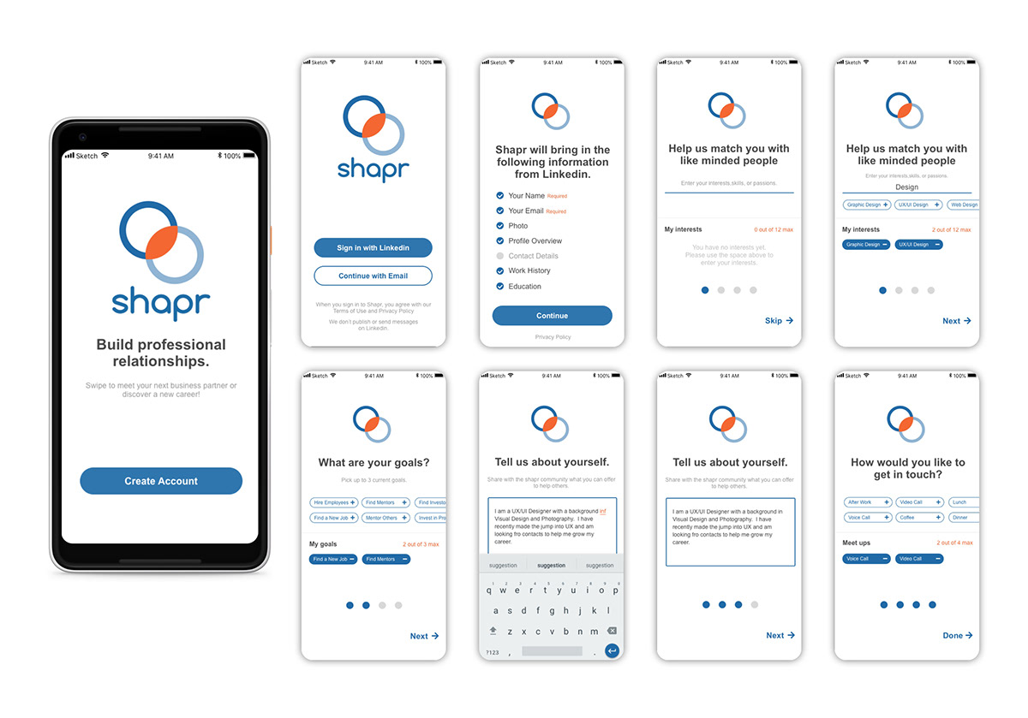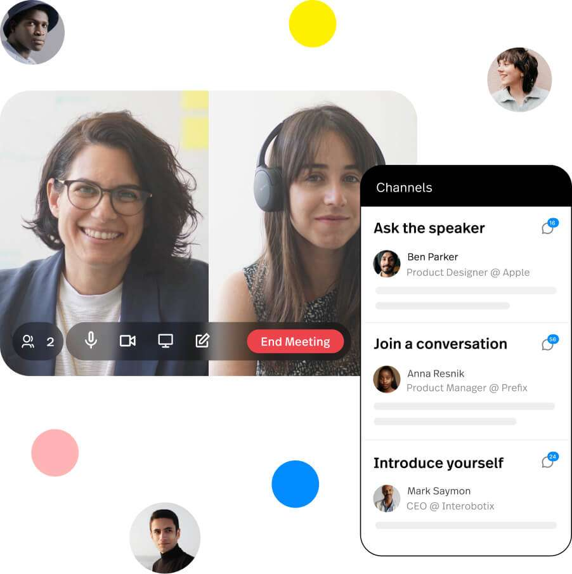

* Features:
  + AI-driven connection suggestions based on profile on Shapr.
  + Event-focused networking capabilities in Bizzabo.
* Limitations:
  + Limited by user base and event participation.
  + Shapr focuses more on general networking than event-specific.

**Virtual Business Card Exchange - CamCard & Haystack**

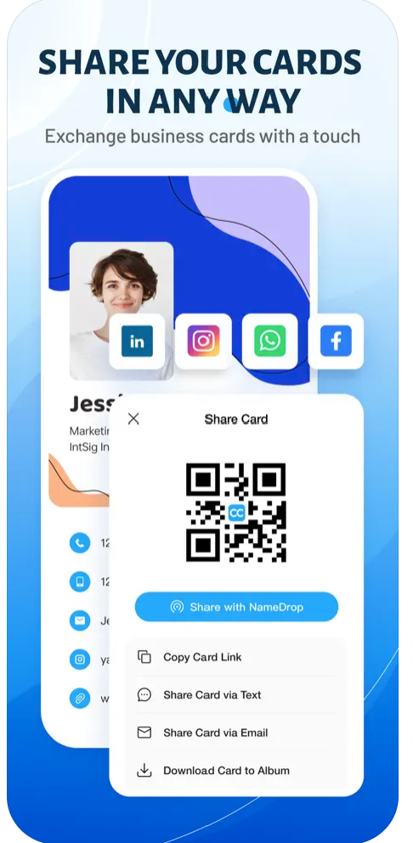

* Features:
  + Digital card creation and exchange via QR codes.
  + OCR technology for scanning physical cards in CamCard.
* **Limitations:**
  + Not integrated into all networking or event apps, requiring separate use.

**Personalized Agenda Planners - Whova & EventBrite**

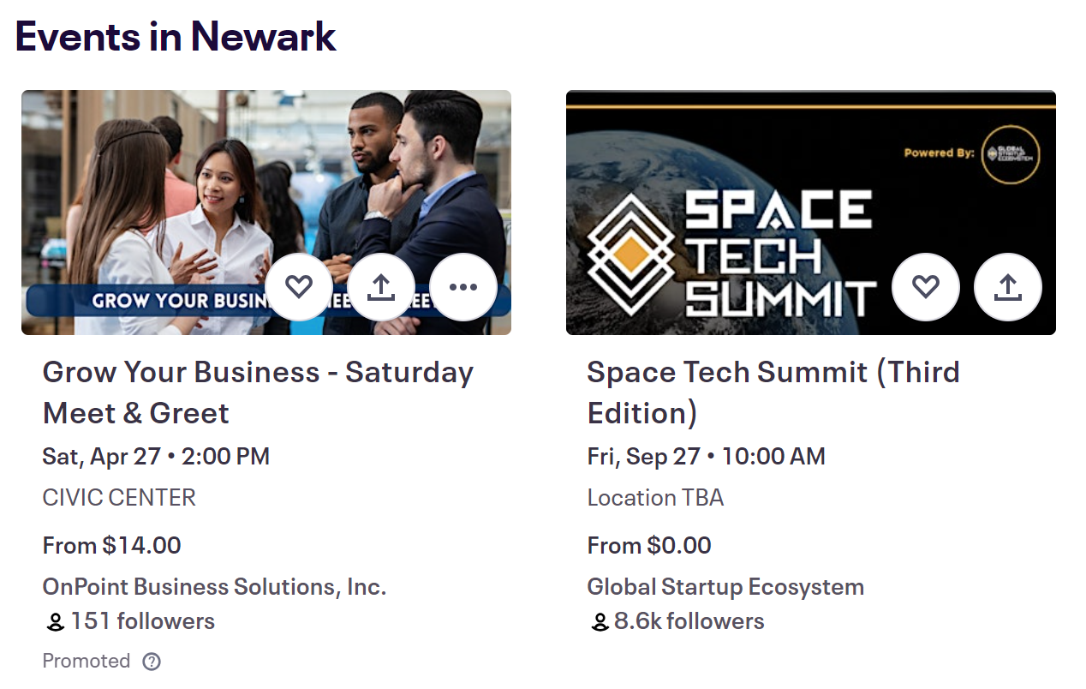

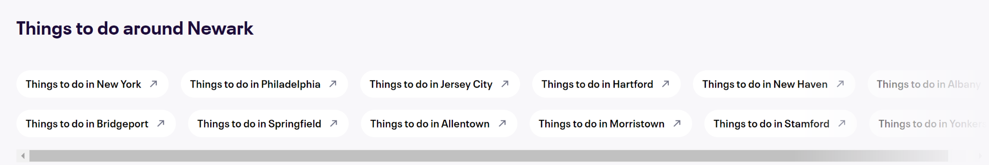

* Features:
  + Customizable event agendas.
  + Integration with personal calendars.
  + Session reminders and meeting scheduling.
* Limitations:
  + May lack deep integration with specific conference platforms.
  + Not universally used across all events.

**AI-Powered Matchmaking for Networking - Grip & Brella**

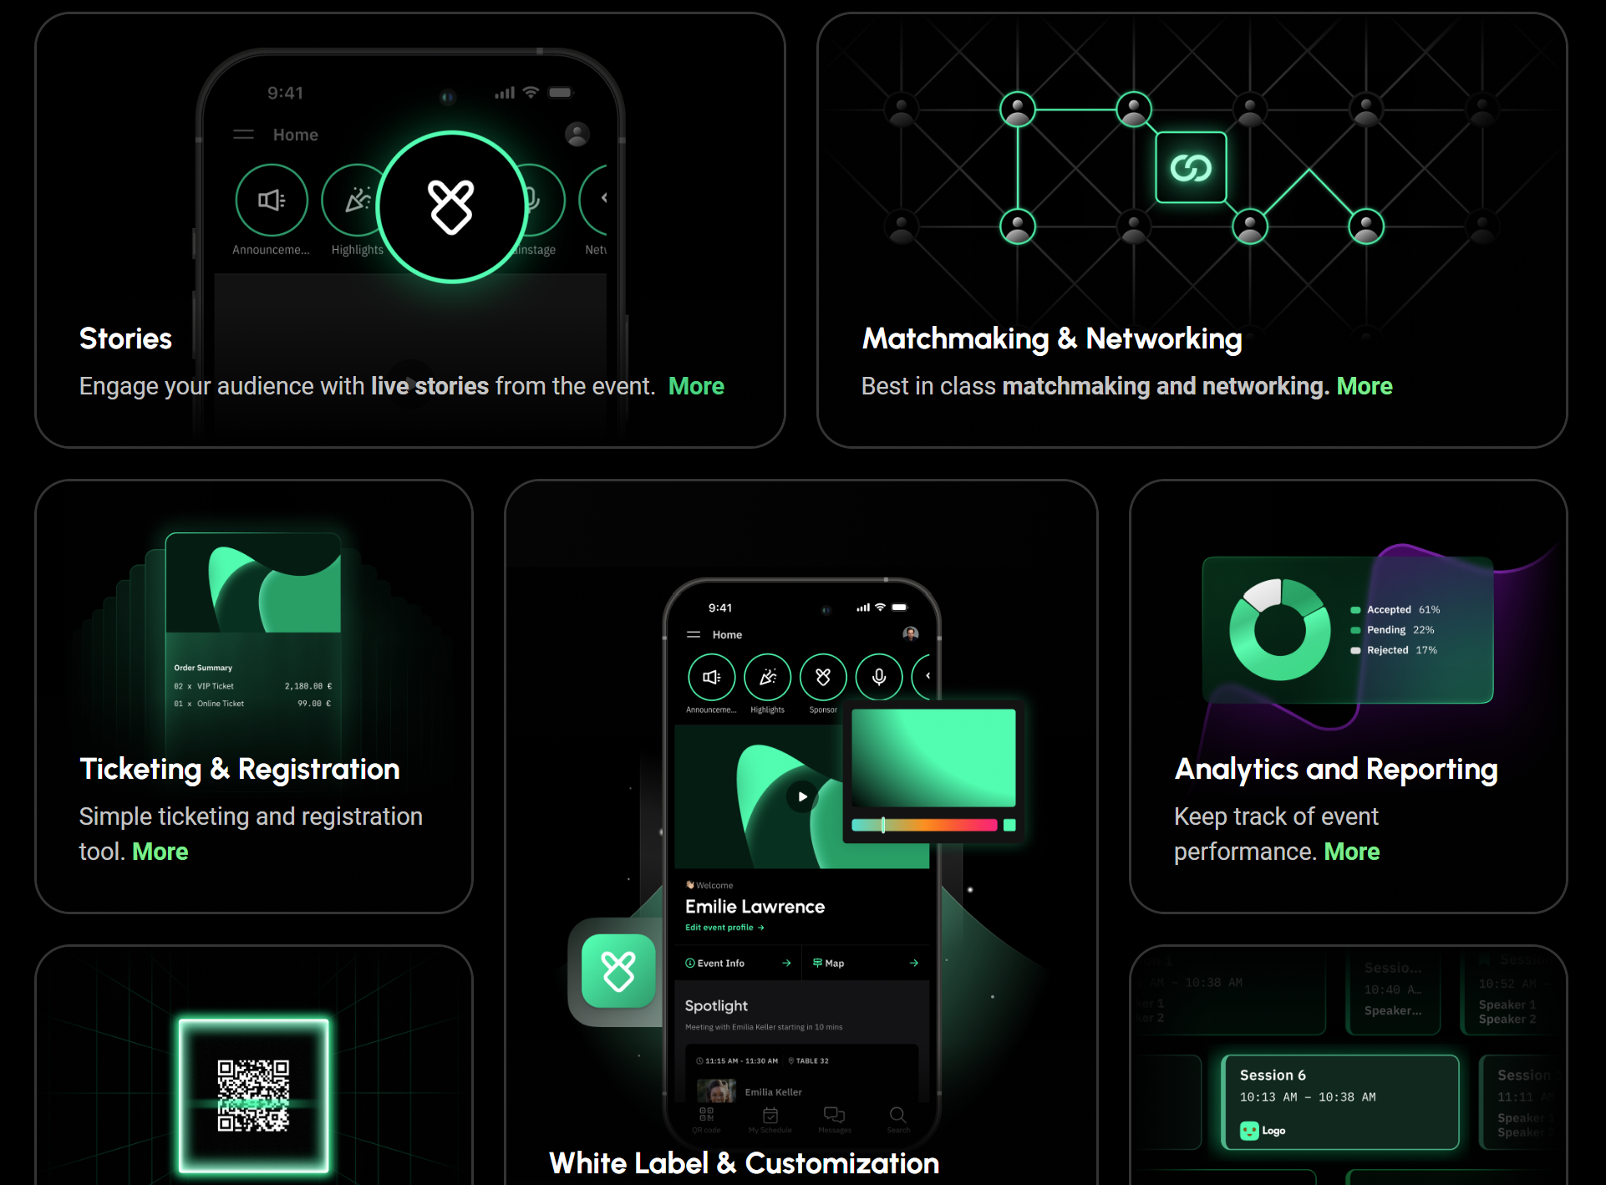

* Features:
  + Matchmaking based on professional interests and goals.
  + Scheduling targeted meetings or suggesting sessions.
* Limitations:
  + Dependence on event organizers' adoption.
  + Effectiveness reliant on comprehensive user profiles.

**Interactive Conference Platform - Slido & Poll Everywhere**

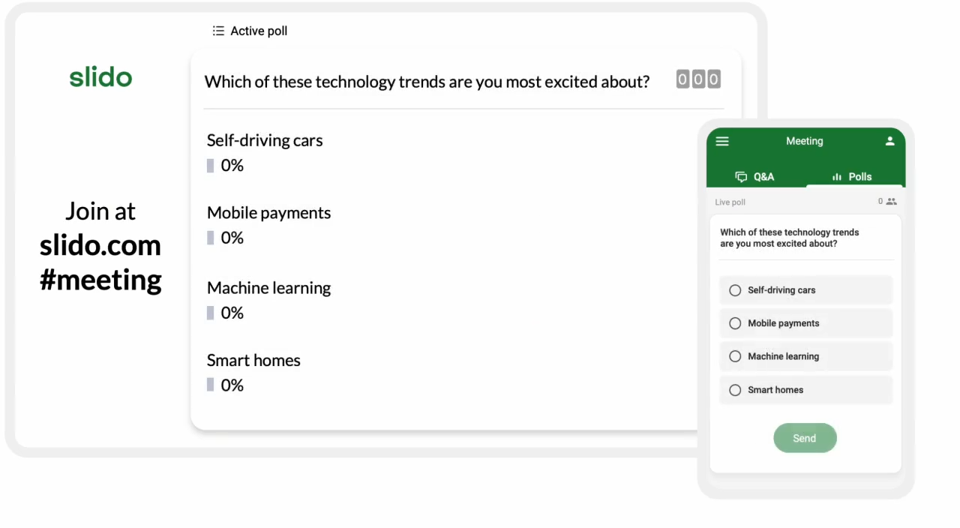

* Features:
  + Real-time polling, Q&A sessions, and feedback.
  + Interactive discussions integrated with presentations.
* Limitations:
  + Requires presenter or event organizer integration.
  + Might not support deep networking features.

**Digital Note-Taking and Follow-up Tools- Evernote & Microsoft OneNote**

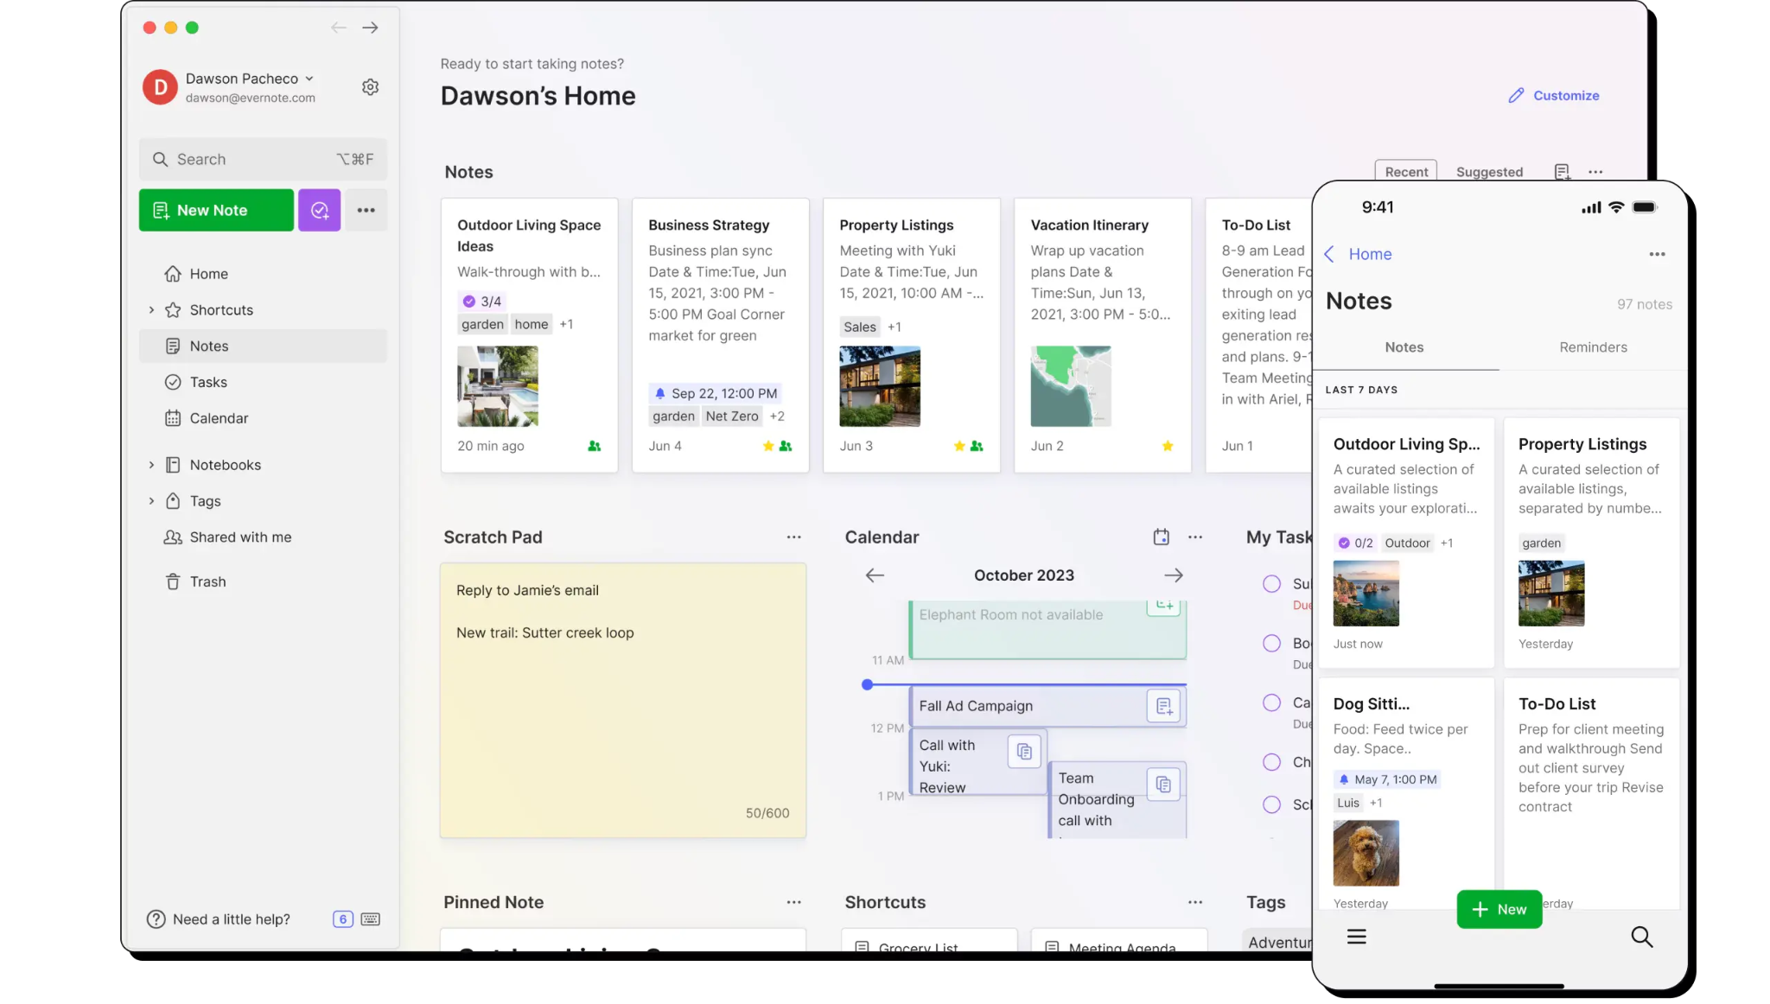

* Features:
  + Comprehensive note-taking with tagging.
  + Can organize follow-up actions, though indirectly.
* Limitations:
  + Lack of direct integration with CRM systems for follow-up
  + Not specifically designed for conference networking.

**Virtual Reality (VR) Networking Events - AltspaceVR & vFairs**



* Features:
  + Virtual event spaces with avatar-based interaction.
  + Can simulate networking environments or host virtual conferences.
* Limitations:
  + Requires VR hardware for full experience.
  + Might not replicate the depth of in-person networking for all users.

**Conferences Insights Dashboard - Pathable & Attendify**

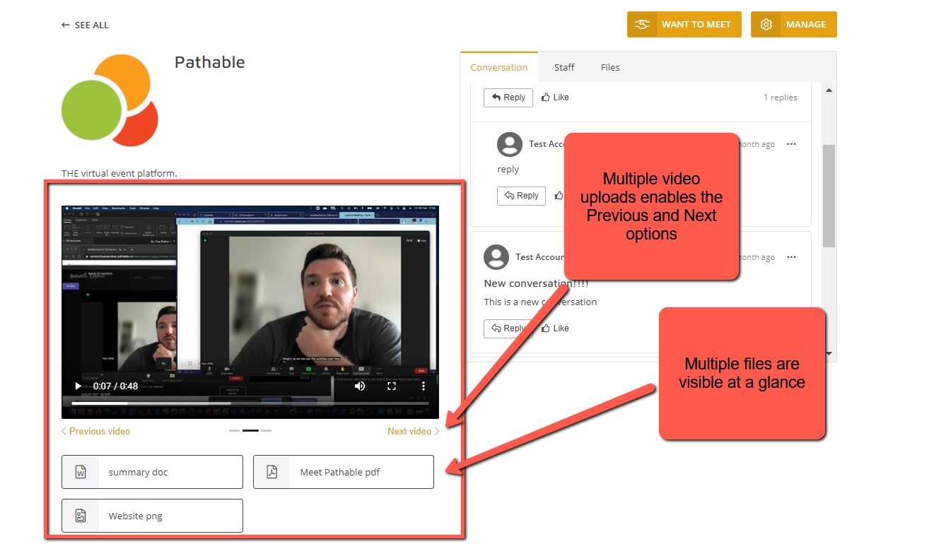

* Features:
  + Attendee engagement analytics.
  + Session attendance tracking.
  + Engagement levels with content and networking.
* Limitations:
  + Primarily designed for event organizers, not attendees.
  + Insight depth varies by platform adoption and integration.

**Mentorship Matching Platforms - Ten Thousand Coffees, MentorCity**

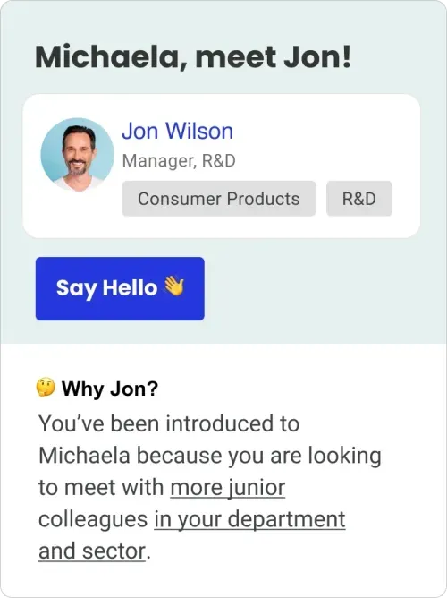

* Features:
  + Automated matching based on goals and interests.
  + Facilitates mentorship connections and advice sharing.
* Limitations:
  + Limited by the active user base and engagement.
  + May not focus specifically on event-based networking.

**Feedback and Recommendations Engine - Grip, Zerista**



* Features:
  + Personalized event recommendations based on past feedback.
  + Session and speaker rating systems.
* Limitations:
  + Effectiveness depends on historical data and user input.
  + Recommendations might not cover all possible events.

Students

|  |  |  |  |
| --- | --- | --- | --- |
| **Technological Aid** | **Existing Apps/Platforms** | **Features Offered** | **Limitations** |
| Lecture Note-Taking Apps | Notion, Evernote | - Comprehensive note-taking with multimedia support.  - Organization and collaboration features for group projects. | - Limited free tier features.  - May require additional storage space for multimedia notes. |
| Homework and Assignment Management | Trello, Todoist | - Task organization with due dates and priority levels.  - Collaboration features for group projects and study groups. | - Limited integrations with educational platforms.  - May lack specialized features for academic use. |
| Online Study Groups | Discord, Slack | - Real-time communication with text, voice, and video chat.  - Integration with other productivity tools for file sharing and collaboration. | - Limited to virtual interactions, may lack in-person engagement.  - Slack doesn’t offer more than 2 people huddle anymore for free |
| Career and Internship Platforms | LinkedIn, Handshake | - Professional networking with alumni and industry professionals.  - Job and internship search with filters for industry, location, and company size. | - Limited access to premium features without subscription.  - Effectiveness depends on profile completeness and networking efforts. |
| Language Learning Apps | Duolingo, Rosetta Stone | - Interactive lessons covering vocabulary, grammar, and pronunciation.  - Gamification elements to encourage consistent practice. | - Limited depth compared to formal language courses.  - May not offer advanced levels of language proficiency. |
| Study Planning and Time Management | Forest, Focus Booster | - Pomodoro technique timers for focused study sessions.  - Gamified features to reward productivity and discourage distractions. | - Effectiveness may vary depending on individual discipline.  - Limited customization options for study plans. |
| Academic Resource Sharing Platforms | Course Hero, StudyBlue | - Access to study guides, lecture notes, and practice quizzes.  - User-generated content for peer-to-peer learning and collaboration. | - Limited availability of resources for niche or specialized subjects.  - Quality and accuracy of user-generated content may vary. |
| Digital Textbook Platforms | Chegg, VitalSource | - Access to a wide range of digital textbooks and study materials.  - Highlighting, note-taking, and search features for efficient studying. | - Subscription fees or per-book purchase required for access.  - Some textbooks may not be available in digital format. |
| Fitness and Wellness Apps | MyFitnessPal, Headspace | - Tracking of exercise, diet, and overall wellness goals.  - Guided meditation and mindfulness exercises for stress relief and focus. | - Limited effectiveness without consistent usage and input.  - May not replace professional advice or treatment for serious health issues. |

## Claims Analysis

[ChatGPT Link](https://chat.openai.com/share/997af004-82df-41eb-bfe0-51215484149f)

Professor

|  |  |
| --- | --- |
| **Category** | **Details** |
| **Details** | **A detailed conversation between Dr. Julian Torres and Dr. Sarah Chen about challenges of encryption in cybersecurity, highlighting plans for future research collaboration.** |
| **Positive Aspects (+)** | **Enhanced Networking Efficiency:** When users tap badges, notifications prompt them to connect, streamlining the initial interaction.  **Contextual Connections:** The app enhances relevance by showing connections and mutual interests  **Post-Interaction Engagement:** A chatbot facilitates the creation of post-meeting notes and follow-up actions.  **Comprehensive Professional Profiles:** The app provides detailed and expandable business cards that include background information and links to professional sites.  **Recognition of Attendees:** Julian recognizes Dr. Chen from her prior work and presentation.  **Enhanced Knowledge Sharing:** The discussion allows both Julian and Dr. Chen to share their experiences and insights, enriching each other’s understanding of current issues in encryption and cybersecurity.  **Professional Relationship Building:** The conversation paves the way for developing a professional relationship based on mutual interests and respect.  **Interactive Icebreakers:** Suggested icebreakers help initiate conversations, reducing awkwardness and fostering engagement.  **Cultivation of Confidence:** Overcoming initial awkwardness to initiate the conversation demonstrates and builds Julian’s confidence in professional settings. |
| **Negative Aspects (−)** | **Privacy Concerns:** Scraping information from various online profiles might raise privacy and data security issues.  **Over Reliance on Digital Interactions:** Heavy reliance on technology for networking could detract from more personal, face-to-face interactions.  **Dependence on Accurate Data:** The app’s effectiveness is contingent on the accuracy and timeliness of the scraped information.  **Follow-up Reliability:** The effectiveness of networking often depends on diligent follow-up, which if not pursued, can result in missed opportunities for deeper collaboration and relationship building. |

Student

|  |  |
| --- | --- |
| Aspect | Details |
| Context and Background | Sarah Johnson, a junior IT student at NJIT, actively engages in various networking activities to expand her professional network within the IT community. Despite her active participation, Sarah faces challenges in organizing and maintaining her growing list of networking contacts. |
| Key Events | Participates in webinars, workshops, and hackathons. |
| Challenges and Decisions | Attends orientation events, club meetings, and networking mixers. |
| Analysis of Key Elements | Contact Organization |
| Description | Implementing effective strategies for organizing and maintaining networking contacts are crucial for Sarah's academic and professional success. |
| Positive Aspects (+) | Enhanced accessibility and efficiency in networking interactions, facilitating personalized relationship-building within the IT community. |
| Negative Aspects (−) | Initial time investment and potential overwhelm in adapting to new organizational methods, requiring ongoing maintenance for sustained effectiveness. |

|  |  |
| --- | --- |
| Aspect | Details |
| Context and Background | Sarah Johnson, a junior IT student at NJIT, actively engages in various networking activities to expand her professional network within the IT community. Despite her active participation, Sarah faces challenges in organizing and maintaining her growing list of networking contacts. |
| Key Events | Participates in webinars, workshops, and hackathons. |
| Challenges and Decisions | Organizing Networking Contacts. |
| Analysis of Key Elements | Follow-Up Reminders. |
| Description | Implementing effective strategies for streamlining follow-up processes are crucial for Sarah's academic and professional success. |
| Positive Aspects (+) | Sarah's ability to promptly follow up with contacts strengthens her professional relationships and increases the likelihood of collaboration opportunities, enhancing her networking effectiveness. |
| Negative Aspects (−) | While technology facilitates communication efficiency, excessive dependence on digital tools may lead to a lack of interpersonal connections and hinder the development of meaningful professional relationships. |

|  |  |
| --- | --- |
| Aspect | Details |
| Context and Background | Sarah Johnson, a junior IT student at NJIT, actively engages in various networking activities to expand her professional network within the IT community. Despite her active participation, Sarah faces challenges in organizing and maintaining her growing list of networking contacts. |
| Key Events | Attends networking webinar. |
| Challenges and Decisions | Managing time effectively to participate in networking activities alongside academic responsibilities. |
| Analysis of Key Elements | Networking Insights. |
| Description | Implementing effective strategies for gaining insights from networking activities are crucial for Sarah's academic and professional success. |
| Positive Aspects (+) | By gaining valuable insights into industry trends, market opportunities, and potential collaborators, Sarah can make informed decisions that align with her career goals and enhance her professional development through networking. |
| Negative Aspects (−) | While actively engaging in networking activities is beneficial, there's a risk of spreading oneself too thin and becoming overcommitted, which can lead to burnout and a decrease in the quality of interactions and relationships formed. |

|  |  |
| --- | --- |
| Aspect | Details |
| Context and Background | Sarah Johnson, a junior IT student at NJIT, actively engages in various networking activities to expand her professional network within the IT community. Despite her active participation, Sarah faces challenges in organizing and maintaining her growing list of networking contacts. |
| Key Events | Organizes and attends Women in STEM club meetings |
| Challenges and Decisions | Prioritizing attendance at networking events. |
| Analysis of Key Elements | Integration with Calendar and Email. |
| Description | Implementing effective strategies for integrating networking events with calendar and email systems are crucial for Sarah's academic and professional success. |
| Positive Aspects (+) | Sarah's improved ability to prioritize networking events allows her to focus on those that are most relevant to her career objectives and interests, maximizing the value of her participation and optimizing her time investment in networking activities. |
| Negative Aspects (−) | While implementing new strategies for prioritizing networking events, Sarah may face a learning curve as she navigates unfamiliar techniques or tools. This initial challenge might require some time and effort to overcome but can lead to significant long-term benefits once mastered. |

Tech Entrepreneur

|  |  |
| --- | --- |
| Aspect | Details |
| Context and Background | Mia prepares to showcase her AI-driven educational platform at the International EdTech Innovators Summit, intending to network with global tech innovators.. |
| Key Events | Mia marks the summit date, updates her professional profiles, and plans her strategy for presenting and networking at the event. |
| Challenges and Decisions | Mia needs to decide how to effectively present her platform, stand out to potential collaborators, and navigate the challenges of different time zones. |
| Analysis of Key Elements | Summit as a Networking Hub - Positive: Offers a platform for showcasing innovations and forming global connections. Negative: Risk of information overload and limited time for individual connections |
| Description | The summit presents an occasion for Mia to expand her network and find collaborators for her new tool designed to overcome time zone barriers in the tech community. |
| Positive Aspects (+) | - Visibility for Startups: The summit is an opportunity to gain visibility for new tech ventures.  - Direct Feedback: Real-time feedback from diverse summit participants.  - Collaboration Prospects: Meeting potential investors and collaborators face-to-face. |
| Negative Aspects (−) | - Time Management: Balancing presentation time with networking opportunities.  -Competitive Environment: The challenge of distinguishing her platform in a crowded market. ​ |

|  |  |
| --- | --- |
| Aspect | Details |
| Context and Background | Mia attends the summit, ready to demonstrate her platform and engage with potential collaborators and investors. |
| Key Events | Mia presents at her booth, participates in discussions, and leads a focused group session on global tech collaboration challenges. |
| Challenges and Decisions | Engaging the audience, handling questions, and identifying serious collaboration and investment leads. |
| Analysis of Key Elements | Engagement and Demonstration - Positive: Interactive platform to demonstrate her product's value. Negative: Risk of not reaching all target audiences due to parallel sessions. |
| Description | Mia takes an active role in summit proceedings to create momentum for her platform and the proposed collaboration tool.. |
| Positive Aspects (+) | - Networking Effectiveness: Quality interactions with focused groups.  -Investor Interest: Capturing the attention of potential investors for her collaborative tool. |
| Negative Aspects (−) | - Diluted Attention: With many events happening, it might be hard to keep attendees' focus.  -Scheduling Conflicts: Overlapping sessions could lead to missed opportunities |

|  |  |
| --- | --- |
| Aspect | Details |
| Context and Background | After the summit, Mia reflects on the event and plans her follow-up actions. |
| Key Events | Organizing contacts, evaluating feedback, and planning the development of the new collaboration tool. |
| Challenges and Decisions | Determining which feedback to incorporate into the tool's development and prioritizing follow-up meetings. |
| Analysis of Key Elements | Post-Summit Communication - Positive: Solidifies new connections through personalized follow-up. Negative: The time-consuming nature of thorough follow-ups. |
| Description | Systematic follow-up to maintain momentum and capitalize on summit opportunities. |
| Positive Aspects (+) | - Potential Partnerships: The potential to form partnerships based on summit interactions.  -Informed Development: Using summit feedback to refine her tool. |
| Negative Aspects (−) | - Resource Allocation: Ensuring that the effort put into follow-ups yields results.  - Feedback Overload: Managing and integrating a diverse range of feedback |

## Key Path Scenario

[**Loom Video**](https://www.loom.com/share/c220827f2d9d414a90b21b2982d41c88?sid=22ec3fd6-42d7-4b28-ab7e-9ab6c6fe9501)

[Key Path Prototype](https://app.uizard.io/p/fbe18f2e) (Click “overview” tab at the top)

[ChatGPT Link](https://chat.openai.com/share/f12a5424-3ba5-42dd-8ceb-6fb683d31c4a)

1. **NFC Badge Tap Notification Screen:**
   * Julian meets Sarah Chen. They tap their NFC-enabled badges and Julian's phone vibrates and displays a notification card that slides up from the bottom of the screen.
   * Screen Requirements:
     + Informs that badges were tapped and with whom (Sarah Chen)
     + Includes a call to action- “Open Icebreaker app”
     + Includes name of app ‘Icebreaker’
2. **Confirmation and Data Exchange Screen**
   * Julian taps on "Accept", and the screen opens a new meeting card for Sarah Chen. Sarah’s basic ‘business card’ is displayed alongside some relevant links and common topics as well as icebreakers. Julian quickly expands the business card to learn more.
   * Screen Requirements
     + Name, Occupation, Photo
     + Where and when the meeting takes place
     + Link to LinkedIn (Professional Profile), Research Gate, and ACM site
     + Things in Common section
     + Ice Breakers Section: Displayed beneath the profile link, this area lists suggested icebreakers generated by AI, based on the analysis of both Julian's and Dr. Sarah Chen's profiles.
     + Conversation Button: Option to provide further details about his interaction with Sarah
     + Back button: Returns to “My Connections” screen
3. **My Connections Screen**
   * After his exchange with Sarah, Julian reopens the app. He opens the “My Connections” page and sees his recent connection, Sarah Chen.
   * Screen Requirements
     + Lists recent connects
     + Shows sort by
     + Shows name, profile picture, time, location
     + Button to view profile and add notes
     + Search feature
4. **Note taking Assistant Page**
   * Julian wants to consolidate the information from his meeting with Dr. Sarah Chen and prepare thoroughly for future interactions. He uses the app, equipped with an AI chatbot, to organize and reflect on their discussion.
   * Screen requirements
     + Name and photo of connection
     + Chatbot asks if they would like to start a conversation
     + The chatbot asks Julian structured questions to catalog the meeting's details
     + Text and Voice Input: Julian can choose to type his responses or use voice-to-text functionality to speak his notes directly into the app.
5. **Follow-Up Page** 
   * Julian moves to the Follow-Up page in the conference app. This page is specifically designed to help Julian review and act upon the notes and suggestions generated during his AI-assisted conversation regarding his meeting with Dr. Sarah Chen.
   * Screen Requirements
     + Dr. Sarah Chen’s photo, name and title
     + Meeting Recap: A brief summary of when and where Julian and Dr. Chen met
     + Structured Notes Display: organizes the notes Julian created with the help of the AI chatbot
     + Action Items List: Based on the conversation details logged in the previous section, the page lists suggested follow-up actions.

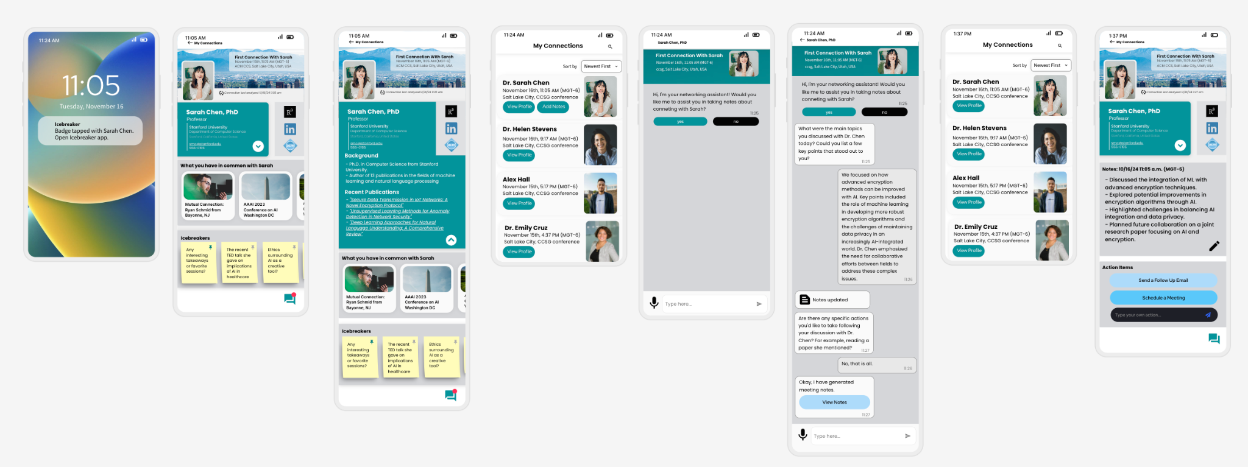

# Appendix:

**Previous Presentations:**

[4/29 Presentation](https://docs.google.com/presentation/d/19qy7M8Fm9r_VBcBIbHrtrz-voX3uDLUkYzZOBF9XNgg/edit?usp=drive_link)

[4/22 Presentation](https://docs.google.com/presentation/d/1_6F05I-3iUyw25zypmmgyPXg3wAh3ioL-ZRJ8WaafnA/edit?usp=drive_link)

[4/15 Presentation](https://docs.google.com/presentation/d/1bE02gZ8mHEq2c3hZcY4ojLO5C2OLNxoM3CTWJoAcLQU/edit?usp=drive_link)

[4/8 Presentation](https://docs.google.com/presentation/d/1sSjzsbNJAzzDmfzbg8wv_dHiVXKTKNSr_8iMhNNg-Os/edit?usp=drive_link)

[3/25 Presentation](https://docs.google.com/presentation/d/1MqkU0NkjHEA0mUnqOTpVQfjU937z6ZtKKK8P-K0B34s/edit?usp=drive_link)

[3/18 Presentation](https://docs.google.com/presentation/d/1j9qiYj9ZODfRsL9-RMmGWb51CxRENd0oVS6lwEy0o4I/edit?usp=drive_link)

**Previous Report:**

[FULL REPORT](https://docs.google.com/document/d/1THsRgUAG-oq7r3B8yMfPjztnfX6zNdSixKK5Qf8zSTo/edit?usp=drive_link) Working draft as of 4/8/24

**Root Concept Table** (See Previous Presentations)

**Stakeholder List** (See Previous Presentations)

**Initial Target Demographic Breakdown** (See Previous Presentations)

**Persona List/ Personas**

[4/1 Personas- Professors](https://docs.google.com/document/d/18s7g4Cu5kdPoYYvzOKuYCtvIxHC6l_pDWhRsqxk1Ds0/edit?usp=drive_link)

[4/1 - Personas- Students](https://docs.google.com/document/d/1ZaSymr_Drducyj_OERPVnMcxHYap_CSxbifCTCAfjW4/edit?usp=drive_link)

[Personas - Students](https://drive.google.com/drive/folders/1wKsb3zlOrDTr4cGCgRDmA1hcVa4UiKbn?usp=drive_link)

[Personas Revised](https://docs.google.com/document/d/1fWCV4UOCGjKiKYlLugvWyU96Y78XqvrGHlHdsh2ilNI/edit?usp=drive_link)

[Revised Personas](https://docs.google.com/document/d/1H7jJXgSgBiOyZelYfHBBlPIi3E1Pg_73K7iJFNhwXdQ/edit?usp=drive_link)

[Revised Personas.pdf](https://drive.google.com/file/d/1SPIM5kHkLFw50Cb8Y-kjkUIqGZMhtkpi/view?usp=drive_link)

**Problem Scenarios**

[5/2 Problem Scenario](https://docs.google.com/document/d/1lgETIPNYPOEMreWIIZ9R1YLzi9VtielD3QTgXhev4yg/edit?usp=drive_link)

[4/29 problem scenario](https://docs.google.com/document/d/1QyKLgFdJkHufCsmByozaxWMk32hfmQaS_9sH4Sc7Kw4/edit?usp=drive_link)

[4/22 problem scenario](https://docs.google.com/document/d/19PlQBR2fS1V5vU7FGxIWNAAACDwGzgsuB1IBK-_7xDY/edit?usp=drive_link)

[4/22 Problem Scenario- IS661](https://docs.google.com/document/d/1zHlEkFKi_c-vlwg2JD0XwYpP-0B13HX4yGCNUgtWyzY/edit?usp=drive_link)

[4/15 problem scenario](https://docs.google.com/document/d/16V43dXB_22sCXauItJtsciOVJpIE-pqwOaRIbYgaJaY/edit?usp=drive_link)

[4/1 Problem Scenarios](https://docs.google.com/document/d/18aecgY2eI1UIOUcpZrBqlrWgtEfRvgFv2IlaRKanpHw/edit?usp=drive_link)

[Sarah Johnson - Semester](https://docs.google.com/document/d/1B6wupbKYNNAytMWF3oBUy4oGSXtsG_kgiuJtLN1kdyc/edit?usp=drive_link)

[3/25 Problem Scenarios](https://docs.google.com/document/d/13FozioHGivADCbpiWEj1fEJGur0Jkyn132iARJezLfw/edit?usp=drive_link)

[Problem Scenario - Sarah Johnson](https://docs.google.com/document/d/1huTxECNKeNi72_uXJlvp3dPzIUFi4ail5u7h0VfInxk/edit?usp=drive_link)

[Problem Scenarios 3/19](https://docs.google.com/document/d/1vqIQtBzqcpqgWTJk-ijjumoPWRt7eKVT7xsYGlgOjT4/edit?usp=drive_link)

**Claims Analysis**

[3/25 Claims Analysis](https://docs.google.com/document/d/18eZRFjNPdgQCHyjRt-bzRPvp9mR6xYYeTjqLMa0xgYI/edit?usp=drive_link)

[3/18 Claims Analysis](https://docs.google.com/document/d/1rmPzH_kOAaJDudZ54UczKxoCO7QzhD2uK-bLkxSmD00/edit?usp=drive_link)

[Claim Analysis Sarah Johnson](https://docs.google.com/document/d/1Q4oUNxvTpme3Xn_85QcrhQyOyQFHrVoB2Ih9Ak9bTO0/edit?usp=drive_link)

[Claims Analysis 4/3](https://docs.google.com/document/d/1TKMpczyhbDh0xkpWgf5SGhJmCEgu17zqhAvu2P6A6KE/edit?usp=drive_link)

**Activity Scenario**

[5/2 Activity Scenario](https://docs.google.com/document/d/1s7ma-OQgMHxC1qzOlAYPpKPK5Ih-RXrGybSyWJx4f64/edit?usp=drive_link)

[4/29 Activity Scenario](https://docs.google.com/document/d/1N93jUPtYqcAsTHtbWTINeq6WbAy-lePtioo5QmIX5kM/edit?usp=drive_link)

[Activity Scenario 4/22](https://docs.google.com/document/d/13QAD0cFl_l8NUnR_Qsl99uTg_JQ3Ji5gNenNicoOZRs/edit?usp=drive_link)

[4/1 - Activity Scenario](https://docs.google.com/document/d/1jzecv8q5PPR09-N6Q5PAP-wXbH9HVCRQ0yGc1sjIb14/edit?usp=drive_link)

[3/18 Activity Scenarios](https://docs.google.com/document/d/1EMy2XLAonHLxHWB5CyDTU_uIMvLwW3-S9GQoEyGrMgI/edit?usp=drive_link)

[Activity Scenario - Sarah Johnson](https://docs.google.com/document/d/1z8pVfSbxPcxKrEqmYj2KEXI8ZJ87CYheNw9GtRAaWoo/edit?usp=drive_link)

**Tech Audit**

[App Descriptions_Tech Audit Notes](https://docs.google.com/document/d/1BEZkvqDF5sCgrdqEcZlhAOvx0wQN3vfYQYoy2fSqvB0/edit?usp=drive_link)

[Tech Audit for Feature Suggestions](https://docs.google.com/document/d/1nNIgWBJlaKWNkJxn6zDoeDWlBmbFisl749AnVaW7y98/edit?usp=drive_link)

[Tech Audit](https://docs.google.com/document/d/1yHEQ5IuTpNHEryqDPzBnGRfy9q5MsNTdCN_T7YdXJ3Y/edit?usp=drive_link)

**Claims Analysis**

[Claims Analysis 4/3](https://docs.google.com/document/d/1TKMpczyhbDh0xkpWgf5SGhJmCEgu17zqhAvu2P6A6KE/edit?usp=drive_link)

[Claim Analysis Sarah Johnson](https://docs.google.com/document/d/1Q4oUNxvTpme3Xn_85QcrhQyOyQFHrVoB2Ih9Ak9bTO0/edit?usp=drive_link)

[3/25 Claims Analysis](https://docs.google.com/document/d/18eZRFjNPdgQCHyjRt-bzRPvp9mR6xYYeTjqLMa0xgYI/edit?usp=drive_link)

[3/18 Claims Analysis](https://docs.google.com/document/d/1rmPzH_kOAaJDudZ54UczKxoCO7QzhD2uK-bLkxSmD00/edit?usp=drive_link)

**Key Path Scenario**

[5/2 Key Path](https://docs.google.com/document/d/1-f3CH141QRnI3SWr8-kDA-_c8385TGjPND1pjzG3OPE/edit?usp=drive_link)

[Keypath Scenario](https://docs.google.com/document/d/1TS00BZu8hp98OwovAWIVPisRNr-VaXJLBSK1Rsf4xR8/edit?usp=drive_link)